*Mas Hamilton s PowerLever offers stand  
alone access control without batteries.*

Standard Key Coding Systems

MZ!/ //■ ■/ /? ! ^ *

/ The Bayonet Cylinder

<CO

X

<c

-J

aro

«CL

Open Invitation to a Vault

’

f Jr Jr / jm , y? g /

The 1997 Acura Ignition

jrw J § l ; jF # | •

CCTV: New Ways of Learning ALOA’s All-New Web-Site and

Full Coverage of ALOA 2001 in Baltimore

THE OFFICIAL PUBLICATION OF ALOA-AN INTERNATIONAL ASSOCIATION OF SECURITY PROFESSIONALS

September 2001

j

f

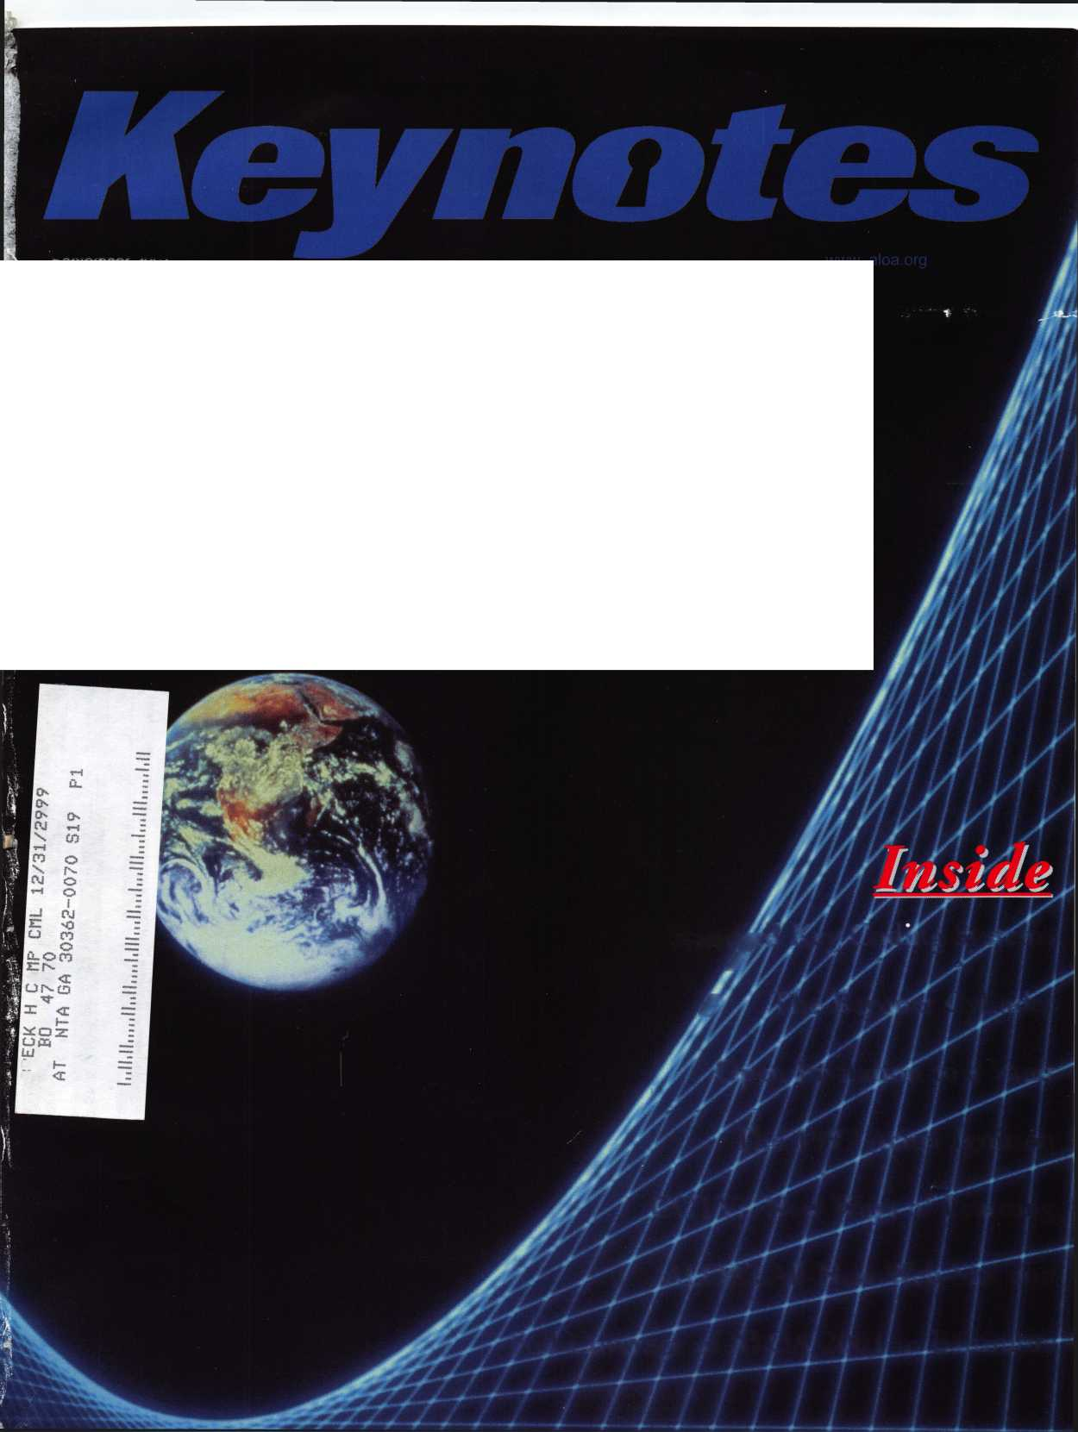

**AL®A**

|  |  |  |  |  |  |
| --- | --- | --- | --- | --- | --- |
| O 1 | r\ | i | n | i < | D |
| A. \J  r o s e m o n | | it, | U  i 11 | r x  i n o i s | |

Reflecting tomorrow

July 22 - 28, 2002

Rosemont Convention Center • Hyatt Regency O'Hare

wwn



VA 4M£^

**Members Ship for Less**

Choose Airborne Express...

^-**( ...acfossanystate... )** ( ...across the country... ) ( ...or around the world. )-^

Rely on Airborne Express for exceptional service,  
guaranteed delivery and the best possible rates!

* Guaranteed delivery for your peace of mind.
* Dedicated member support at 1-800-MEMBERS.
* Easy to use online package tracking.
* Additional discounts when using an  
  Airborne Express Drop Box.

|  |  |  |  |
| --- | --- | --- | --- |
| r |  |  |  |
| tnooscxne Best Value* | r Zone 2  | (within 150 miles) | Zone 5  (600-1,000 miles) | Zone 8 ^  (1800+ miles) |
| ■ Airborne Express | $9.72 | $11.34 | $12.15 |
| ] UPS | $12.25 | $14.50 | $15.75 |
| ^FedEx | $12.75 | $15.00 | $16.25 J |

Call 1-800-MEMBERS

It's easy to save! Choose from next morning, next afternoon, second day and international services. There are no minimum number of shipments, and no contracts required for these special rates.

**Get Your FREE Airborne Express Starter Kit**

Return this coupon for your free Starter Kit and special Airborne account.

ContactTitle

Company

Address (no PO Boxes)

CityStateZip.

Phone Fax Email

I am a member of Associated Locksmiths of America

What will your average monthly shipments with Airborne be? 0 0-9 □ 10-19 0 20+ □ 125+

□ Tell me how I can save even more by pre-purchasing Flight-Ready5** letters and packs with no weight limits.

<S

**1-800-MEMBERS** Y.

(1-800-636-2377,8 am-7 pm, ET) J



**1 -888-461 -4664** \

**(fax toll-free, 24 hours)** **J**

Code: AL0A N5*Y107

**/IIRBORNE**

**EXPRESS,**

moabx-12/00 PR1000A

* Rates shown are for an 8 oz. overnight letter express and are subject to change. Airborne Express rates based on average shipping volume of 10 or more packages per month. Call for pricing if averaging less than 10 shipments monthly. Member rates are even lower when averaging 20 or more shipments per month.

Call 1-800-MEMBERS for this volume pricing.



Contents

September 2001

Volume 47, Issue 8

(0

111

D

<

Li.

-A

10

Train Wrecks, Chemical Fires and a Fantastic Show

ALOA 2001 coverage.

By Claire Cohen, CML

14

Access Control — My, How Far We’ve Come

Mas Hamilton’s PowerLever offers stand along access control without batteries.

By Sal Dulcamaro, CMl|

18

Institutional: Locksmiths and the Standard Key Cod­ing Systems

Record keeping with regards to the key coding system is as important as anything the institutional locksmith does.

By Roger Yost, CML, CPS

22

Traditional: The Bayonet Cylinder

As much as it resembles one, this is not your standard Adams Rite type MS lock and cylinder. Here’s how to service - and tell the difference.

By David Thielen, CML

26

Safes: An Open Invitation

Vault work can be very difficult and yet very educational at the same time. When you get a call to do some vault work, it’s usu­ally a thrilling ride either way.

By Greg Perry, CML, CfS

30

Automotive: 1997 Acura Ignition

Servicing and instillation tricks for a very common auto appli­cation.

By Kevin Whitesides, CRL

34

CCTV: New Ways of Learning

CCTV has come a long way, and our latest convention is proof that there’s plenty left to learn.

By Paul Chandler, CRL

DEPARTMENTS

2

Contents

President's Journey

Applicants

8

Core

25

Upcoming Events 38

Legislative Update 40

Classifieds

42

Associate Member Listing 44

Back Page

VISIT OUR WEB SITE AT:  
[www.aloa.org](http://www.aloa.org)

Keynotes

September 2001

Executive

|  |  |  |  |
| --- | --- | --- | --- |
| Editor | Jim DeSimone | Executive Director | Charles W. Gibson, Jr., CAE |
|  | [ecitor@aloa.org](mailto:ecitor@aloa.org) |  | [charlie@aloa.org](mailto:charlie@aloa.org) |
| Technical Editor | David Lowell, CML, CMST | Director of Information Technology | Randy McChristian |
|  | [david@aloa.org](mailto:david@aloa.org) |  | [randy@aloa.org](mailto:randy@aloa.org) |
| Editorial Advisor | John D. Cannon, CML | Convention & Meetings Manager | Kelly Carr, CMP |
|  | [jdcannon@worldnet.att.net](mailto:jdcannon@worldnet.att.net) |  | [kelly@aloa.org](mailto:kelly@aloa.org) |
| Advertising Sales | Susan Haverkamp |  |  |
|  | 121 Davis Street | PRP/Education Manager | David Lowell, CML, CMST |
|  | Nacogdoches, Texas 75961 |  | [david@aloa.org](mailto:david@aloa.org) |
|  | Phone: (936) 569-7172  VoiceMail: (208) 248-8893 | Operations/Membership Manager | Mary May |
|  | e-mail: [adsales@aloa.org](mailto:adsales@aloa.org) |  | [mary@aloa.oig](mailto:mary@aloa.oig) |
| Contributors | Jerome Andrews, CML | Government Affairs Manager/ | Tim McMullen |
|  | Paul Chandler, CRL  Claire Cohen, CML | Chapters & Regional Associations Liaison | [tim@aloa.org](mailto:tim@aloa.org) |
|  | Brian Costley, CML, CMST | Comptroller | KathyJ. Romo |
|  | Ray D'Adamo, CML  Sal Dulcamara, CML | Network Specialist | GregJackson |
|  | Billy Edwards, CML  Dan Graffeo, CRL,CMST | Membership Coordinator | Shelly Jett |
|  | A.J. Hoffman, CML | Convention & Meetings Assistant | Karen Lyons, |
|  | Jeff Nunberg, CML, CMST |  | [Karen@aloa.org](mailto:Karen@aloa.org) |
|  | Mikey Oehlert, CPL, CPS  Randy Simpson, CML | PRP/Education Coordinator | Ashley Manson |
|  | Robert Stafford, CML | Accounting Coordinator | Kathy Stokes |
|  | Dave Thielen, CML  Greg Perry, CML,CPS | Mail Room Coordinator | Humberto Cerda |
|  | Tom Seroogy  Charles Stephenson, CPS | Receptionist | Alin Valdez |
|  | Dennis Watanabe, CML, CMST |  |  |

Additional contact information for the

ALOA Board and most Keynotes authors is available through “Locksmith Search’”

on the ALOA Web site- [www.aloa.org](http://www.aloa.org) or by contacting the ALOA office at 3003 Live Oak Street;

Dallas, TX 75204;

**(**800**)**532**-**2562**;**

FAX (214)827-1810; e-mail [aloa@aloa.org](mailto:aloa@aloa.org).



Mission Statement: The Associated Locksmiths of America, Inc. is dedicated to enhancing the professionalism, education and ethics among locksmiths and those in related sectors of the physical security industry. With approximately 10,000 members in the United States, Canada and the freeworld, ALOA is poised to help members obtain the knowledge, the strength, and the confidence to perform their role in the physical security field with pride and dignity. But it is only through active involvement and participation that ALOA can fully achieve its potential—and can help members to achieve theirs.

Policies: Keynotes® is the official publication of the Associated Locksmiths of America, Inc. (ALOA). Keynotes® acts as a moderator without approving, disapproving, or guaranteeing the validity or accuracy of any data, claim, or opinion appearing under a byline or obtained or quoted from an acknowledged source. The opinions expressed by the authors do not necessarily reflect the official views of ALOA. Also, appearance of advertisements and new products or service information does not constitute an endorsement of products or services featured by the Association. The Association does not accept responsibility for the inaccuracy of any data, claim, or opinion appearing in this publication, due to typographical errors on the part of the authors, Association staff or its agents.

Editor’s Note: This publication is designed to provide accurate and authoritative information in regard to the subject matter covered. It is provided and disseminated with the understanding that the publisher is not engaged in rendering legal or other professional services. If legal advice and other expert assistance is required, the services of a competent professional should be sought.

Authors’ Payment: Payment for eligible submissions to Keynotes will be based on the following criteria: topic, time spent and past contributions. Authors who regularly submit to Keynotes are generally paid a higher rate. The latter is especially true of authors who write to fit specific editorial needs and submit said copy by Keynotes deadlines. As a general guideline: Average payment for a 750 word, business or ‘light’ technical article would be $200. Payment for a 1500 word article involving significantly higher time and research efforts would be $400.

Payment will not be offered for articles submitted by ALOA employees or members of the ALOA Board of Directors (unless material is of a technical nature), nor for articles submitted by a company that promote that company’s products or services. ALOA reserves the right not to pay for articles submitted by an individuals) that promote a particular company’s products or services.

Disclaimer: The Associated Locksmiths of America, Inc., (ALOA), reserves the right to refuse any article for any reason. Additionally, ALOA reserves the right to edit, amend or modify any article submitted for publication in order to preserve technical accuracy, clarity, fairness or grammatical correctness. ALOA will make the best efforts to notify the author of any changes. The extent of ALOA’s liability for any article or information contained therein will be a notice of cor­rection or retraction in the next possible issue.

Keynotes® (ISSN 0277 0792) is published monthly except for the combined June/July issue by The Associated Locksmiths of America, Inc., 3003 Live Oak St., Dallas, TX 75204-6186. Telephone: (214) 827-1701; FAX (214) 827-1810; e-mail [aloa@aloa.org](mailto:aloa@aloa.org). Subscription rates for members—$15.00 per year. Second class postage paid at Dallas, Texas. POSTMASTER: Send address changes to: Keynotes, 3003 Live Oak St., Dallas, TX 75204-6186. © Copyright 1999, All rights reserved. No part of the contents may be reproduced or reprinted in any form without prior written permission of the publisher.

President

Randy Simpson, CML (713) 780-7026 [president@aloa.org](mailto:president@aloa.org)

Secretary

John D. Cannon, CML (703) 960-6413 [jdcannon@worldnet.att.net](mailto:jdcannon@worldnet.att.net) Directors, Northeast John C. Magee, III (856)845-3434 Peter Sarailian, CRL (201) 947-6291 [psarailian@yahoo.com](mailto:psarailian@yahoo.com) William L. Young, CML (610) 647-5042 Directors, Southeast Vincent Formon, CML, CPS (901) 324-2910 CfdM' Donald E. Rule, CML (601) 324-2658 [rulecml@ebicom.net](mailto:rulecml@ebicom.net)



V

Directors, North Central

Mark E. Blum, CML, CPS (517) 482-5809 [mblum@arq.net](mailto:mblum@arq.net) John Soderland, CML, CMST (414) 327-5625 [ncdirector@aloa.org](mailto:ncdirector@aloa.org) Director, South Central Randy L. Simpson, CML (713) 780-7026 Directors, Southwest Gordon R. Racine, CML (719) 384-4707 [swdirector@aloa.org](mailto:swdirector@aloa.org)

Julie McCluney, CRL (714) 636-5652 [swdirector@aloa.org](mailto:swdirector@aloa.org) Director, Northwest Scott L. Henke, CRL, CPS (907) 248-3785 [action@alaska.net](mailto:action@alaska.net)

Director, Associate Members

David F. Matthies (727) 541-5536

[dmatthies@southemlock.com](mailto:dmatthies@southemlock.com)

Trustees

Dallas Brooks (334) 826-8990 David M. Lowell, CML, CMST (800) 532-2562 Edwin Toepfer, RL (416) 225-5589 JohnJ. Greenan, CML, CPS (773) 486.2030

Past Presidents

1999-2001 JohnJ. Greenan, CML, CPS 1997-1999 Dallas C. Brooks 1995-1997 David Lowell, CML, CMST 1993-1995 Breck Camp, CML 1991-1993 Henry Printz, CML 1989-1991 Evelyn Wersonick, CML, CPS 1987-1989 Leonard Passarello, CPL 1985-1987 Joe Jackman, CML 1983-1985 Stanley Haney, CPL 1981-1983 Louis LaGreco, CPL 1979-1981 John Kerr, RL 1977-1979 Clifford Cox, CML 1974-1977 Charles Hetherington 1972-1974 Gene Laughridge 1970-1972 William Dutcher, RL 1968-1970 Constant Maffey, RL 1966-1968 Harold Edelstein, RL 1964-1966 William Meacham 1962-1964 Robert Rackliffe, CPL 1960-1962 Edwin Toepfer, RL 1956-1960 Ernest Johannesen

***September 2001***

***Keynotes***

3



j o u c □ e y

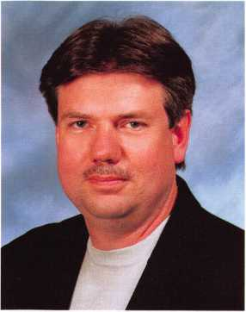

Hello Members,

It is my pleasure to be President of our great association. My predecessors worked hard to organize our Board over the past few years. This work has paid off in the form of a solid gov­ernance document with policies and goals. As president of ALOA my primary duty will be to chair the Board. My term will be spent working with and developing Board members. It is our charge to lead and guide our association. Your input can affect each of these decisions. Let us know what you think. E-mail me at [president@aloa.org](mailto:president@aloa.org). Together let’s make a strong associa­tion that will be a leader to the security profession.

Your board will be working on developing two key issues.

Legislation:

This issue is relevant to each of our members. Like it or not, some form of legislation restrict­ing electronic security is being drafted in some state as I am writing this letter. The Board will be reviewing our current “defend and support” policy and developing support for our model law that can be introduced in each state. Our position will be to protect the current environ­ment that allows locksmiths to install electronic security devices. Our industry needs laws that will protect and ensure our future involvement in all forms of security hardware. Hats off to our Government Affairs Manager, Tim McMullen, for his work on the North Carolina bill 942, which has passed. This is a major win for our industry. Call Tim at the office with any issues regarding registration or licensing in your states.

Web:

Hit the web site. Changes are coming and new features are being added daily from education to paying your membership dues. Interaction is the focus. New directions mean a new site. Since its introduction some 4 years ago we are currently on our 3rd round of changes.

Many thanks to all who were on hand for our 45th annual Security Expo. Our show attracted members from every state and territory except Rhode Island and Wyoming. On hand were 1881 exhibitors and distributors and over 1900 attendees for a total of 3700 visitors on the Expo floor. ACE held 14,119 student class hours of instruction. ALOA Security Professionals obtained 1,232 certificates. 283 registrants tested for the PRP. All of this adds up to the Best Security Expo of its kind in the world. Please check [www.aloa.org](http://www.aloa.org) for details about our next event in Chicago.

Sincerely,



Keynotes

September 2001



***Visit our Website on  
www. stamcctv. com***

THE COMPLETE

CCTV PROGRAM ON CD-ROM  
FOR STAFF TRAINING AND  
PRODUCTIVITY ENHANCEMEN

STAM Insight has been  
developed to enhance CCTV  
skills and productivity with  
many different uses.

10 Productivity

10 System Drawing  
10 Estimation  
**# CCTV** Training  
10 **CCTV** Reference  
10 Sales/Demo  
10 System Design  
10 Staff Evaluation

|  |  |  |  |  |  |  |
| --- | --- | --- | --- | --- | --- | --- |
|  |  | INFOMATE | WORKMATE  m | ULTIMATE | |  |
| g | [ ' CCTV Content | 10 hours | 10 hours | 14 hours | | |
| 1 | CCTV Calculators |  | f  | |  | f | m |
| ©  cc | Demonstration Tool |  |  |  | f | □ |
| >•  .ts | | Estimation | HO | r /" | r | r |  |
| p  a. | Drawing | HO | 1 / | f | i |
| | Internet Enabled | Ho | f r r | | f | 1 |
|  | f Pre-Test | Ho | MO | I | Z |  |
| c*  c  w | I ■ ■ ; '  Quizzes | NO | ; £_{_ | |  |  |
| £ | Knowledge Assessment | NO | » r | | z |  |

Sold in Over 50 Countries

Distributed by:

3003 Live Oak Street  
Dallas,Texas 75204



COPYRIGHT © 1996 Security Training and Marketing Pty Ltd.  
All rights reserved ACN 057 006 541

Country

Tel: ( )

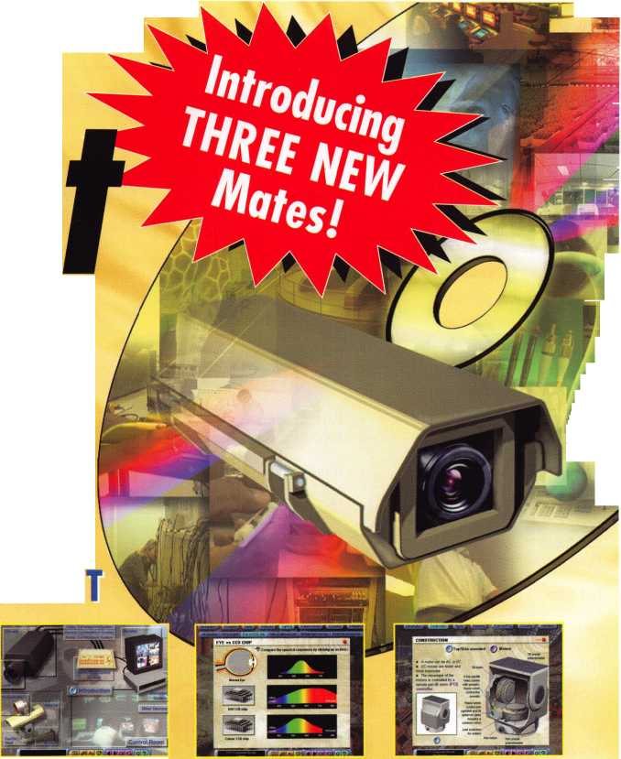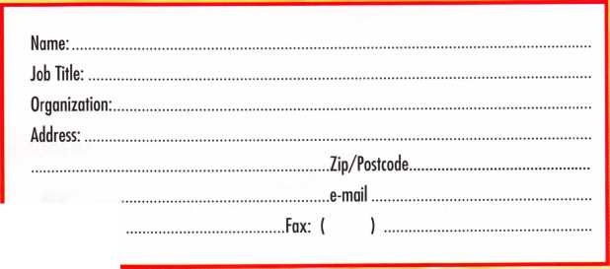

|  |  |  |  |  |  |  |  |  |  |  |  |  |
| --- | --- | --- | --- | --- | --- | --- | --- | --- | --- | --- | --- | --- |
|  | Ai | D | D | li | ca |  | n |  | tS f°r m e m 1 | b e r s 1 | h i i | P |
| 1 | r |  | | | | | | | | | |

AZ

Phoenix

Michael J Hartman SPONSOR: William Lee

Pinetop

Eugene N Prestwich SPONSOR: Milton Hendrix

CA

Anaheim

A1 Patten

SPONSOR: Daniel Enriquez

Antioch

Raul C Balangan

Burbank

Khachig E Manoogian SPONSOR: James Kleman, CPL

Calabasas

Benjamin Leiderman

El Cajon

Kevin R Meadows SPONSOR: C D Lipscomb

Oakland

Tracie Mennenga SPONSOR: Charles Cunningham

FL

Miami

Carlos 0 Santacruz SPONSOR: Juan F Pujol

Ormond Beach

Dennis J Heath SPONSOR: Gordon Racine

Tallahassee

Jesse H Stephens SPONSOR: David Davis

Tampa

Gary L Cooper SPONSOR: Samuel Stanford

GA

Acworth

Glenda A Risner

Carrollton

Mark E Marlow SPONSOR: Charles Vaughn

IL

Chicago

Jaime Mendez SPONSOR: Otilio Arzola Kelvin Wing SPONSOR: Otilio Arzola Rafael Venegas SPONSOR: Otilio Arzola

KY

Burlington

Robert F Deck

MA

Taunton

Kenneth Avilla

SPONSOR: Michael Ehrlich, CML

MD

Baltimore

William E Brant SPONSOR: TomDemont K M Goins Alan Hoolin

SPONSOR: Robert DeWeese Matthew A Meredith

Fort Meade

Robert M Booher

Gaithersburg

Eric F Arenz

SPONSOR: Gregory Jacobson

Laurel

Carroll T Allen, III

North Beach

EricJ Svane

MN

Mankato

Jerry D Morrison

MO

Bridgeton

James L Light SPONSOR: Kenneth Km

Fenton

Thomas A Raymond Jr SPONSOR: Kenneth Kim

Florissant

Lawrence E Dickhans SPONSOR: Kenneth Kim

Hannibal

James E Baxter SPONSOR: Kenneth Kim

Imperial

James J Wisnewski SPONSOR: Kenneth Kim

Saint Louis

Michael Kim SPONSOR: Kenneth Km Ellis C Brown II SPONSOR: Kenneth Km Clarence Bueltermann SPONSOR: Kenneth Km Christopher Lambert SPONSOR: Kenneth Km John G McClure SPONSOR: Kenneth Km Tyrone Robinson SPONSOR: Kenneth Km

Washington

Paul M Chambers SPONSOR: Kenneth Km

NC

Havelock

Jamie M Fuller SPONSOR: Ralph Fuller

NH

Enfield

Claire F Walton SPONSOR: Henry Ilsley

NJ

Morristown

Jeffrey G Baldwin

NY

Bronx

David Allen Jr

Conesus

Glenn E Miller

Forest Hills

Scope Rawle

South Ozone Park

James Schubert

Syracuse

Ed Bergsbaken SPONSOR: Chuck Gladd

OK

Enid

Danny L Cornforth

OR

Beaverton

Darin Pfeiffer

PA

Middletown

Patrick A Reider SPONSOR: William Neff Robert L Long SPONSOR: William Neff

TN

Maryville

Linda J Hall

SPONSOR: Marian Swann

TX

Belton

Charles W Newsom CML

Corpus Christi

Weston D Wade

Dallas

Rojelio Martinez SPONSOR: Robert Ashmore

El Paso

Jose Morales SPONSOR: Rick Milliorn

New Braunfels

Jim W Hetchler

San Antonio

Lila M Theis SPONSOR: Ed Moore

VA

Blacksburg

Jeffrey M Hula

Fairfax

Mark R Maurer CML SPONSOR: Raymond Remeika

Garrisonville

Russell W Pearson

Lynchburg

Jennifer L Harder SPONSOR: Claude Bryant

Norfolk

Dwayne A Thierjung SPONSOR: Robert Theirjung

Springfield

Charles L Jewell Jr

Yorktown

Ed Generazio

BAHAMAS

Nassau

Ricardo Johnson SPONSOR: Clinton Harding, CRL

CANADA Edson Alberta

Lawrence A Roome

AL

Calgary

Douglas J Scratch SPONSOR: Craig Smith

ON

Mississauga

Mike Pulsinelli SPONSOR: William McLean

DENMARK

Gillelejen

Michael F Hansen

ISRAEL

Yaune

Nadav Sherman Adalbert B Matyko

JAPAN

Minato-ku

Keiji Iwata

SPONSOR: Nobuharu Nagashima, CRL

Keynotes

September 2001

Name Members

Recruited

Kwok-kei Leung 204

Toshihiro Asano 113

Henry W Raymond 100

Yuriko Yanai 69

Stewart J Levine CML 66

Mary S Ohmit CPL 66

Charles C Robertson CML 65

Jack Hobin CPL 51

William B Neff CML 48

Salvatore J Dulcamaro CML 40

Myeong-Rae Cho 38

Dana L Barnum CML 35

Barry K Leas CRL 35

Danny W Rudd CPL 31

Larry A Warnick CML 31

C Allan Halverson 31

Jeanne G Lodge CML 30

William Lee 28

Lawrence F Smith Jr, CML 27

Anthony J Ramunno CML, CPJ  
Marian M Swann CRL  
James M Watt CML, CPS  
Jeffrey SNunberg CML, CMS  
J Thomas Hood CML  
Jim Williams CRL  
James H Glazier Sr, CML  
Robert F Carroll CPL  
Robert H Stafford CML  
John C Elliott Jr, CML, CPS  
Robert D DeWeese CML  
Jerome L Cohen CML  
Peter K Gauthier CPL, CPS  
Elvis D Hammerschmidt CPL  
Man-Soo Seo  
Diana R Barnum CRL  
James J Cawby CML, CPS  
Eugene R Altobella Sr  
Michael B Groves  
Philip A Rovenolt CPL  
John L Shandy CML  
John S Dorsey CML  
D Michael Lee Sr, CPL  
Robert W Duman Sr, CML  
James E Fowler Sr, CML  
David C Harris CML  
Peter R Hall

Thomas G Vandersteen CML, C  
William P Grant CRL

Wear the Ring



|  |  |  |  |  |
| --- | --- | --- | --- | --- |
| 26 | Keizo TakahashiCRL | 17 |  |  |
| 26 | Walter W Lascar RL | 16 |  |  |
| 26 | Joseph P Ferrero CML | 16 | TLj V, |  |
| 26 | Gary F Teams CPL | 16 |  |  |
| 26 | Michael E Jordan Jr, CML | 16 |  |  |
| 26 | Brian J Reetz | 16 | Basil W Shannon CPL | 11 |
| 25 | Robert C Rodocker CRL | 15 | Calvin G Harris CML | 11 |
| 25 | Kenneth E Kim CRL | 15 | Herbert C Dusenberry CML, CPS | 11 |
| 25 | William JMcElheney CML | 15 | Timothy K Chow | 11 |
| 24 | Jon B Griswold CML | 15 | Dale L Knowles CPL | 11 |
| 24 | Michael D Robinson CRL | 15 | Alvin N Minor | 10 |
| 23 | Russell P Fuller CRL | 15 | Gene EldridgeCPL | 10 |
| 23 | Daniel L Landry Jr | 15 | Ronald P Riggins CML | 10 |
| 23 | James L Hancock CRL | 15 | Lester S Brodsky | 10 |
| 23 | James E Gruber CRL | 14 | Larry L Votaw CML | 10 |
| 22 | Joseph W Whitaker CPL | 14 | Thomas R Smith CPL | 10 |
| 21 | James T Brickler CRL | 14 | William T Straub CML | 10 |
| 21 | Joseph C Fuller CML, CMST | 13 | Richard T Johnson CPL | 10 |
| 21 | Frank D Hartung CML | 13 | Dale V Crosby CPL | 10 |
| 20 | Paul M Souber | 13 | James V Hawley CRL | 10 |
| 19 | Donald H Shiles RL | 13 | Eugene R Altobella Jr | 10 |
| 19 | John A Ilk CRL | 13 | James Bright | 10 |
| 19 | Richard C Sievers | 13 |  |  |
| 19 | Ernest W Wright | 12 |  |  |
| 18 | Rolando Bouza | 12 |  |  |
| 18 | Raymond C Lusk CML | 12 | *ALOA Board of Directors not eligible | |
| 17 | John F Engel CRL | 12 | for membership in the President's Club | |
| 17 | Eric F Veal | 12 |  |  |
| 17 | Thomas J Demont CML, AHC | 11 |  |  |

How can I join the President's Club?

You can earn a membership in this presti­gious club by recruiting just 10 new mem­bers for ALOA.

*Any ALOA member may participate.

What do I get?

When you recruit 10 members, you receive your choice of either a handsome blue blazer with a President's Club crest or our new President’s club ring. For each additional five members you recruit, you receive a lapel pin with gold-filled num­bers, indicating, your recruiting success­es.

You also get the satisifaction of knowing that you are helping your association, helping your industry grow, and you are helping fellow locksmiths achieve suc­cess.

How do I get started?

Contact the ALOA office for a supply of applications (800) 532-ALOA or FAX (214) 827-1810. One President's Club credit is awarded for each new applicant. Credit is awarded only after the membership appli­cation is approved. However, the credit will apply for the period in which the application is received. Failure to identify yourself as the sponsor on the application form at the time it is submitted to ALOA for processing will forfeit any credit.

***September 2001***

***Keynotes***

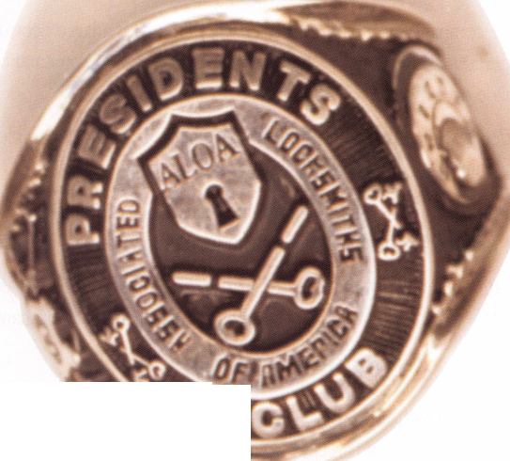

CORE

MOSLER INC. TO CEASE ALL OPERATIONS

Mosler Inc., an integrator of security systems and services, announced today that it has ceased all operations in order to engage in an orderly liquidation of its assets.

The company said that it has been operating with a large debt burden for some time. Additionally, Mosler has faced a number of operational challenges related to the unsuccessful implementation of a new computer system and the integration of its acquisitions made over the last several years.

Effective immediately, all of the approximately 1,800 Mosler employees have been terminated. The company has retained only a small core group of employees to assist in the liquidation process.

Mosler said that it explored a number of actions, including a sale of the company and various restructuring alternatives. The compa­ny said that despite its best efforts, it has determined that an orderly liquidation of the business is its only alternative.

In terminating its operations, the management of Mosler expressed its sincere appreciation to the employees of the company for their hard work and dedication and to Mosler customers for their many years of loyalty.

New Board Sworn In

At the ALOA Convention in Baltimore, the newest members of the ALOA Board of Directors were sworn in. They are:

President

Randy Simpson, CML

Director, Southwest Region **Gordon Racine, CML** Director, Southwest Region **Julie McCluney, CRL** Director, Southeast Region **Vincent Formon, CML, CPS** Director, Southeast Region **Don Rule, CML** Director, North Central **John Soderland, CML, CMST**

The other Board Positions were not open for election.

Annual Award Winners

ALOA Award

The ALOA Award went to Jerome Andrews, CML, for years of tireless service to the profession. The award is given out annually to those who have demon­strated a lifetime of outstanding achievement. (Thus, the A.L.O.A. Award name.)

President's Award

The President’s Award this year went to Joe Lee, who has been instrumental in building bridges between the United States and our large, flourishing chap­ters in Asia and the Pacific Rim. Joe has translated ACE material into Korean and has been a strong proponent of uniting the two regions by streamlining efforts and standards overseas.

Keynotes Author of the Year

The Keynotes Author of the Year for 2001 is Baltimore’s own Claire Cohen, CML. Claire is only the second woman in 20 years to receive the Author of the Year award (Dorothy Friend was the first), and Claire is also only the second woman to become a CML. Her work over the years with Keynotes has been very graciously given and like so many of our authors, she gladly works under difficult deadline situations to contribute to locksmith education and coverage for the members.

|  |  |
| --- | --- |
| CRLs | New Certifications |
| Ruben Beltran | El Paso, TX |
| Randy Erwin | Albuquerque, NM |
| Kevin Hudak | West Chester, PA |
| GUIs | |
| Bob Stafford | Ellington, CT |
| CPSs | |
| Phil Crawford | Montgomery, AL |
| Michael Yarberry | Sellersburg, IN |

8

***Keynotes***

***September 2001***

Mailbox:

Recently, I traveled to Baltimore to spend the week at the Annual ALOA Convention and Security Expo. My goals were to learn something new and to renew friendships. I also attended the ALOA show to represent the California Locksmiths Association and to invite exhibitors to attend the CLA Trade Show on March 23, 2002 at the Disneyland Hotel in Anaheim, CA. My goals were a success.

The classes I chose were very well-represented and I feel that with continued practice, I hope to report some day that I was able to manipulate and open my first safe! Then I will thank Dennis Watanabe, CML, CMST, (and his wife and assistant, Frances), who did a wonderful job in reaching their safe class students. I must thank Allan Halverson and Brooke Berry for opening my eyes to more options in handling digital locks, especially Simplex.

The exhibitors were simply great this year and deserve tremen­dous thanks for being so creative with their booths and making the overall appearance of the show one continuously exciting for me, and I’m sure for all who attended. The Show specials were very generous and I know I spent more than I anticipat­ed. As it was, I needed an extra suitcase to bring back all I bought, plus the literature I managed to pick up.

I enjoyed the Membership Meeting, which had a fine atten­dance to hear outgoing President John Greenan, CML, CPS, give his farewell address, and everybody cheered for all who so graciously received award recognition for jobs well done.

If you skipped the State of the States meeting, you had better revise your agenda for next year and make it a must. The exchange of ideas and progress in many states was reassuring that the locksmith association are here to stay, and will contin­

ue to work to raise the professionalism of the locksmith indus­try for years to come. Many thanks to the staff at ALOA and especially Tim McMullen, who chaired this meeting and watch­es out for legislative action around the country.

As for me, I must thank all ALOA members and staff, because I received the keys to the 2001 Dodge Van that was raffled off at the show this year. I thank you for the thrill of my life and a dream come true. Your warmth in sharing my joy made me feel like a celebrity - a status, I never expected.

So to all again, I say "THANK YOU" and may each of you be blessed in a similar manner. With warm wishes and joy in my heart,

Norman Weisenburger, President of the California Locksmiths Association

New ALOA Site is Up!

Go directly to [www.aloa.org](http://www.aloa.org) now! We debuted our new and improved Web site at the ALOA Security Expo in Baltimore. We've totally revamped the site, including a clean new look with a completely streamlined set of directories, enhanced search engines, expanded news coverage and an on-line store. Don't miss out on this fantastic new tool for members!

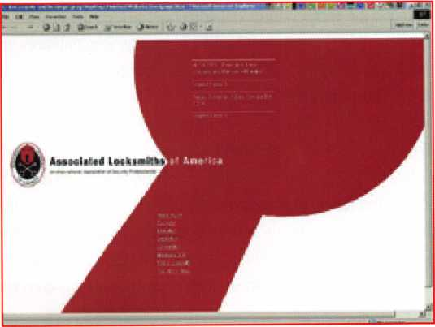

***September 2001***

***Keynotes***

|  |  |  |  |
| --- | --- | --- | --- |
| Train Wrecks, | | By: Claire L. Cohen, CML | |
| and | Chemical Fires | |  |
| a Fantastic snow | | |

Even a massive train derailment, a fire, and a water main break couldn’t stop the 2001 ALOA Security Expo from being a major success. Less than 24 hours before the start of the Security Expo, a 60-car freight train (carrying hazardous chemicals) derailed in a narrow Baltimore tunnel, blocks from the Baltimore Convention Center-the site of the ALOA 2001 Convention. The catastrophe sparked a 5-alarm fire that shut down much of the downtown area. The fire in the tunnel wreaked havoc above the street, causing waterlines to burst and shoot geysers 20 feet into the air, manhole covers to loosen and the pavement to buckle into lumps pushed up by the broken pipes. Roads leading to the city were closed temporarily. Access to the Convention Center was blocked. Fortunately, by the next morning, roads were opened; and the ALOA 2001 activities, which included the ALOA Annual Membership Meeting and the opening day of the Security Expo, were on schedule!

Baltimore’s beautiful Inner Harbor was the perfect setting to wel­come ALOA members, exhibitors and guests to "charm city". Although the high temperature in Baltimore was near 90 degrees, the temperatures outside could not compete with the warmth inside-seeing old friends, renewing acquaintances and the opportunity of meeting new association members, guests and enthusiastic exhibitors.

The ALOA staff and volunteers started preparing for the day’s events very early in the morning. Staff and volunteers could be seen manning the registration booths, setting up meeting rooms, and overseeing the successful operation of the convention. There were a great many behind-the-scenes tasks to accomplish, and with smiles on everyone’s faces, their enthusiasm was conta­gious.

Lines were long but moved quickly as new and old faces con­verged at the registration area to pick up name badges. Later this day (and for two additional days), security professionals from around the world would collect information and literature on the latest products and technologies. They hoped to learn more about the very latest in tools, hardware and software. Everyone was anxious to attend the day’s events.

At the ALOA registration area, I met a man who proudly intro­duced himself as an ALOA scholarship recipient. Pleased to meet so many members of ALOA, he spoke about the fine instructors and intensive classes he had attended all week. He said that he had learned so much as a result of his scholarship, and was glad to be a part of our organization.

Ribbons, showing "ALOA Member", "CRL", "CPL", "CML", "First- Timer", "Volunteer", "President’s Club", etc. adorned name badges. Some attendees had almost a foot of ribbons attached to their name badges! Members who were not “First Timers” were easy to identify. Some past convention collectors had hundreds of souvenir label pins from past conventions adorning hats, shirts and vests.

The Guest Lounge, just upstairs from the convention floor, offered a spot to relax before the convention and was a gathering place to socialize with old friends and make new ones.

The official day’s activities began with the CML / Keynotes Author’s Breakfast. Hosted by David Lowell, CML, CMST, Education/PRP Manager and Jim DeSimone, Editor-Keynotes Magazine, the breakfast gave CML’s and Keynotes Magazine authors an opportunity to hear about new methods of adminis­

Keynotes

September 2001

tering the PRP evaluation. Jim DeSimone, spoke about technical articles being placed on the ALOA website and the revised maga­zine format.

Just before the beginning of the trade show, the ALOA Annual Membership Meeting was conducted. We said goodbye and thank you for a job well done to ALOA President John Grennan, CML, CPS, and we said welcome to Randy Simpson, CML as the new President of ALOA. In his farewell address to the member­ship, John Grennan proudly spoke about the convention:

'You are currendy attending the biggest educational event devot­ed to locksmiths held anywhere in the world. The annual ALOA Convention offers more classes on more subjects than any other educational event anywhere."

Steve Engel, CML, ALOA Scholarship Foundation President, announced generous contributions made to the ALOA Scholarship Fund. Awards were made to John Grennan (outgo­ing President), longtime members and special awards. (Thanks to all for my award, too!).

While registration, breakfasts and meetings were taking place, other members were attending one of the many locksmith edu­cation classes.

The ribbon cutting ceremony ushered in the Security Expo. Attendees poured on to the convention floor where they were hoping to get a first look at new products. How wonderful it was to realize that people from all over the world—Japan, Iran, United Kingdom, the Bahamas & more—were in attendance. Everyone was anxious to begin the 3-days of exhibits; to see demonstrations, to get hands-on experience with products, to pick up new literature, and to talk to factory representatives.

179 exhibitors lined the convention floor. Much could be learned from the proliferation of exhibitors. The products and services offered exhibited represented the best our industry has to offer. There was so much to see and to LEARN!

•Lock manufacturers •Distributors • Computer software

•Safes

•Key duplicating equipment

•Educational programs

•Sales, marketing and insurance companies

•Novelty items

•Tools

• Safe moving equipment

•Architectural hardware

•Van customizing

•Padlocks, hardware

•Local and international associations

•Trade publications

•And MUCH MORE!

And who could pass by the "Nostalgia" booth without looking at the memorabilia of past conventions. There were items dating from 1951 to the present time. T-shirts, lapel pins and other memorabilia were prominently displayed for all to see and remember!

Arm-weary from carrying tons of literature, it was time to rest and relax. It had been quite an educational day! But for some, the first day of Security Expo was not over. The PRP and STPRP examinations were being conducted that evening.

After hours, locksmiths, guests and exhibitors walked around Baltimore’s Inner Harbor, seeing a bit of history along the way. You could tell the locksmiths were in town— and lots of them! All around the harbor area they could be seen wearing some of the T-shirts from the convention and stopping to chat with fellow members.

Time passed so quickly at the 2001 ALOA Convention in Baltimore, MD. The ALOA Security Expo offered us an opportu­nity to talk to security professionals from around the nation and around the world. Seeing old friends, making new friends, and discussing common problems and concerns in our industry all contributed to the success of the convention. Here’s hoping for a year of good health and prosperity. See you at the ALOA 2002 Convention in Rosemont, Illinois -July 20-28,2002 !

***September 2001***

***Keynotes***

Baltimore 2001

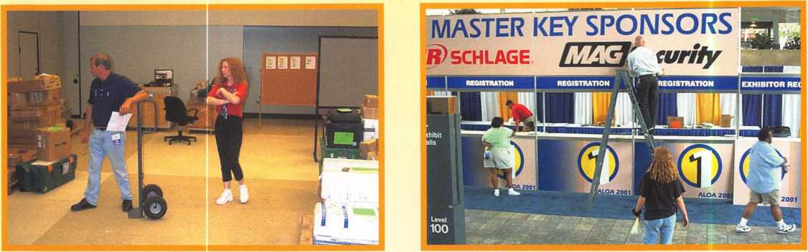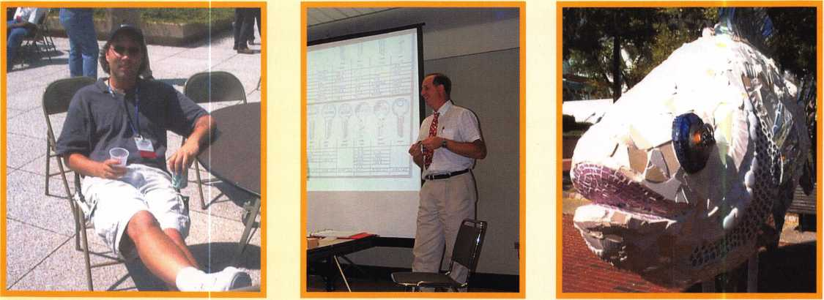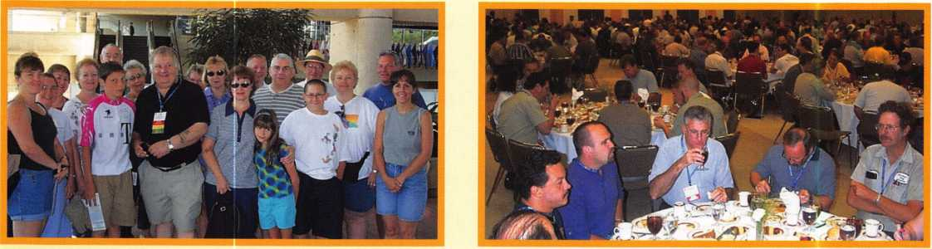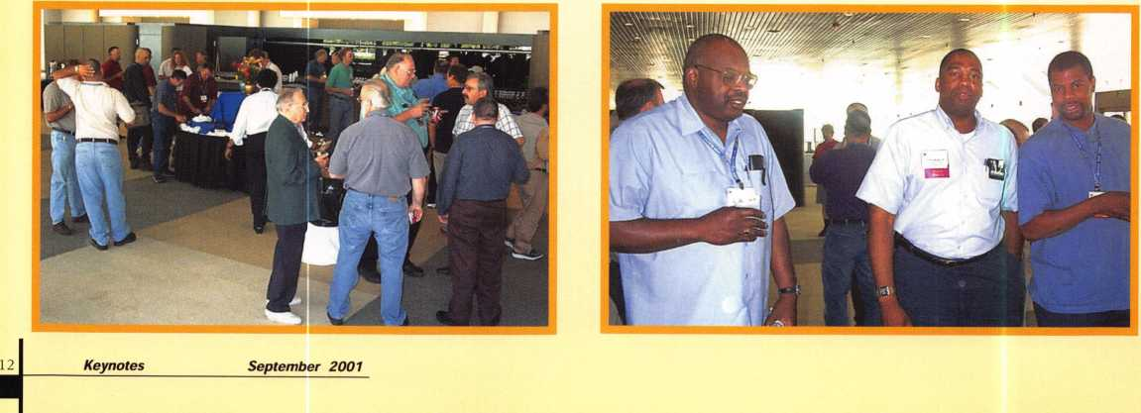

Baltimore 2001

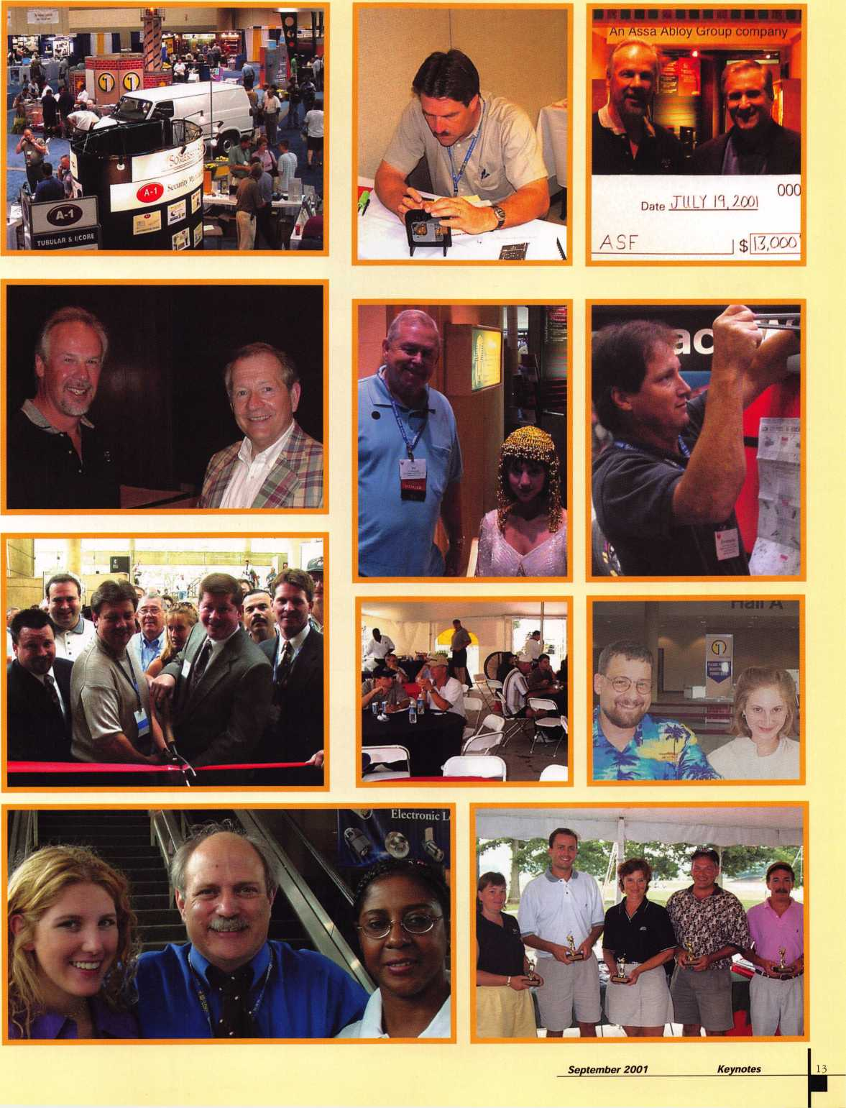

Inside Mas- Hamilton's PowerLever

By Sal Dulcamara, CML

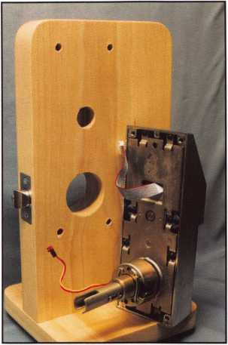

**Photo 1**

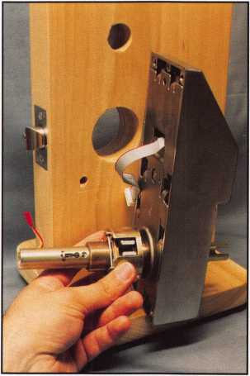

**Photo 2**

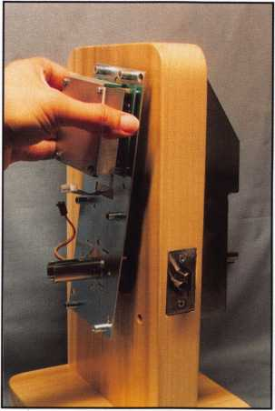

**Photo 3**

When it comes to stand alone (electronic) keyless access control, I know of only one product line currently available that works without batteries. PowerStar technology, developed by Mas-Hamilton, allows the PowerLever series of keyless locksets to operate without being hard­wired or having to deal with battery replace­ment. A power generator contained within the body of the lock unit creates the energy needed for lock operation and program­ming, when the lever handle is turned. Mas- Hamilton was first bought by ILCO/UNICAN some time back. It is now part of KABA, with KABA's recent purchase of ILCO. It is, however, still headquartered in Lexington, Kentucky.

Lock Installation

Although a version of the PowerLever is available as a rim mounted device, it is primarily a cylindrical type lock unit that will install in a modified cylindrical door prep. Photograph 1 shows the modi­fied door prep with the standard 2 1/8 inch diameter cross bore hole. The additional holes are measured and referenced by that preexisting hole. If you are dealing with a door with no prior preparation, you will have to start with that hole location. The PowerLever is a grade 1 lockset and appears to be only available with a 2 3/4 inch back­set, but should work with a door thickness range from 1 3/8 inch to 2 inches.

Five additional holes, beyond the main cross bore hole, are required. The larger 1 inch diameter hole (just above the cross bore hole) is for the system cable that connects the keypad input to the interior electronics. The remaining four smaller holes, in the corner positions, are 11/32 inch in diameter, and are for the thru-bolts that connect the inside and outside assem­blies.

Keynotes

***September 2001***

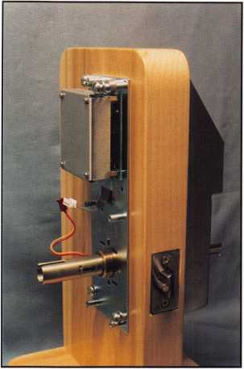

**Photo 4**

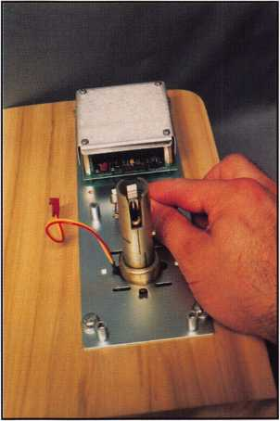

**Photo 5**

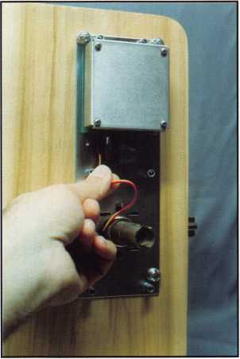

**Photo 6**

A paper installation template comes with the lock for you to identify the hole locations. If you don't want to free hand the installation, I believe a jig is available from Mas-Hamilton. Otherwise, you have the option to use jigs made by independent lock tool manufacturers. Regardless of jig or template, it is generally a good idea to drill inward from each side of the door to minimize the possibility of burrs or splintering. Earlier I mentioned the door thickness range possible if you intend to install the PowerLever. The lock is typically preset for a 13/4 inch thick door, but can be adjusted for the door thickness you need (within the accepted range). Photograph 2 shows the lock chassis assembly being rotated. Counterclockwise rotation will adjust for thicker doors and clockwise rotation for thinner doors. You can see a ribbon cable protruding from the backside of the outside case assembly. The width of half the door thickness should measure from that backside surface to the center of the latch retractor. Also the lock is technically non-handed. Rotating the lock chassis assembly half a turn in either direction will change the handing from right to left or vice versa.

The latch was shown already installed in the lock mount. During the installation process, you should use adequate caution and care when handling electrical wiring and contacts, or any electronic circuitry. Watch for crimping or cutting of wires, too. The lock is intended to be highly resistant to damage from Electrostatic Discharge (ESD) when installed, but can be vulnerable to it during the installation process. You may consider the use of a grounded ESD wristband while you are installing the lock.

After feeding the system (ribbon) cable through the 1 inch hole, make sure that the sole­noid cable doesn't get tangled in the latchbolt mechanism while the lock chassis is placed through the cross bore hole and the latch is mated with the latch retractor.

In photograph 3, the inside backing plate with the electronics assembly is being posi­tioned on the inside surface of the door. The system cable should be guided through the rectangular hole just above the middle of the backing plate. Depending on how the lock is handed and the position of the latch and latch retractor, the solenoid cable will be routed through a hole in the backing plate to the left or right.

The two top mounting screws (with appropriate spacers for the door thickness) and lock washers should be attached but not tightened. Next the two bottom screws (and appro­priate spacers, etc...) should be attached, as in photograph 4. Then all four screws should be tightened.

Photograph 5 has an underside view of the system card that is covered (protected) by a square metal plate called the shield. Do not remove the shield, or you may cause dam­age to the system card. The connectors are inside there. Photo 3 shows a clear view of the solenoid cable, extending from a hole to the left of the inside lock tube. I'm about to plug in the solenoid cable, in photograph 6. The system cable was plugged in earlier. The inside case is shown off to the left of the lock mount in photograph 7. It will be attached to the inside backing plate with six screws. Notice the screwdriver at the base of the mount. It is equipped with a Torx security type tip. I'm not sure if it is standard for all of them, but the unit I assembled had Torx security screws. A screwdriver with a wide variety of security type screwdriver tips (including Torx security) is available from Keedex.

There were two long Torx security screws for the top of the inside case, and four short

***September 2001Keynotes***

in

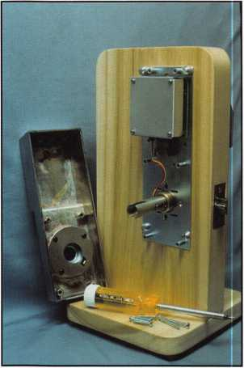

**Photo 7**

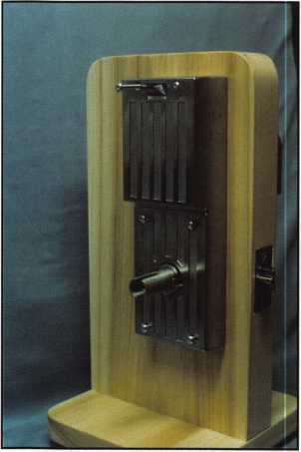

**Photo 8**

**Photo 9**

Tone security screws for the bottom portion. They are all partially fastened in photo­graph 8. They should all be tightened.

The inside lever handle is being attached in photograph 9. You may not be able to see it, but there are two poke holes in the neck of the lever handle tube. We have already made a few considerations for door thickness so far; this is another. For a door thickness of greater than 11/2 inches, the first catch slot will complete the installation of the inside lever handle. If you are dealing with a door thickness of 11/2 inches or less, photograph 10 shows the lever release tool poking into the access hole to compress the retainer. If the door was thinner, the handle could be pushed inward one notch further to catch and retain in a second retainer slot in the lever handle.

Outside Lever Handle Options

Although the PowerLever locksets are designed as keyless electronic units, they do have mechanical key bypass. The type of lock cylinder used will affect the final steps of assembly. A conventional (non-IC) cylinder unit will have a lever handle that can be attached in a fairly conventional way. Position the lever handle and insert the operating key and slightly rotate the key while pressing the handle into place. Door thickness becomes a consideration here, too. A choice of two different lock cylinder inserts, makes you choose between a door thickness of 11/2 inches or less for one, or 1 5/8 inches or more for the other. Like the inside lever handle, there is a second retainer slot for doors of 11/2 inch thickness or less. In that case, you would turn the key while pushing in the retainer (through the poke hole), and push the handle in one notch deeper.

Photograph 11 shows a small format (or Best style) IC type lever handle. There is no external poke hole to access the handle retainer. Instead, you would have to posi­tion the handle, as in photograph 12, and access the retainer from inside the IC cavity.

With a door thickness greater than 11/2 inches, the handle would catch just by applying force inward until the spring loaded catch retained the handle. You would only need to access the retainer from inside for an initial installation on a door that was 11/2 inches thick or less, or if you needed to remove the outside lever handle. I don't illus­trate this step, but you would insert a tool within the "Figure 8" cavity, and internally draw back the retainer. You would either push the handle in further to engage the sec­ond retainer slot (for a thinner door), or pull out on the handle to remove it.

Photograph 13 shows a 6-pin SFIC cylinder with its matching tailpiece. Like many other locksets that accept the small format IC lock cylinders, tail piece sizes will change with IC cylinder length. A 7-pin SFIC cylinder will typically take a slightly shorter tailpiece to account for the slightly longer cylinder. The cylinder is then installed, in pho­tograph 14, with the appropriate control key.

Lock Features

I will not be going into the operation and programming of the PowerLever in this article. I will likely do a follow up article sometime in the near future, to cover that. I will explain, though, some of the basic features and differences between the various models of the PowerLever. Photograph 15 shows the completed lock assembly. The PowerLever Door Lock comes in Models 1000, 2000 and 3000. Externally, there is little

Keynotes

September 2001

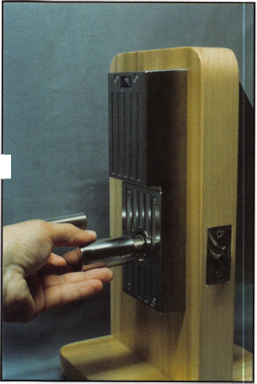

physical difference. Except for the lack of an iButton data port on the Model 1000 (it is the only one without audit capability), the three models are nearly identical. In fact, the installation is virtually the same for all. The internal electronics is where the differences are manifested.

The Model 1000 unit has a maximum of 20 individual access codes and no audit capability. All programming must be done manually at the keypad. Models 2000 and 3000 with the iButton data ports and data keys have the ability to upload and download information. Lock programming can be accom­plished that way, as can lock auditing. Model 2000 has up to 40 user codes, and 430 date/time stamped audit events. Model 3000 allows up to 96 user codes, 943 date/time stamped audit

events, and time zone/ access schedule capability.

If you have customers with a need for keyless electron­ic access, you may want to consider the PowerLever series locks. There are no batteries to replace, and you have various degrees of sophistication with the different models, depending on the needs of your customer. For more information, contact: Mas- Hamilton Group, Inc., 749 W. Short Street, Lexington, KY 40508. Phone: 800/950-4744. FAX: 606/255-2655. Find them on the web at: [www.mas-hamilton.com](http://www.mas-hamilton.com).

Look for any updates or corrections of my articles at my web page: <http://home.earthlink.net/~lockwriter>. Look under the link at "Tech Article Addendum".

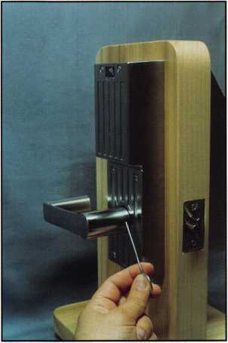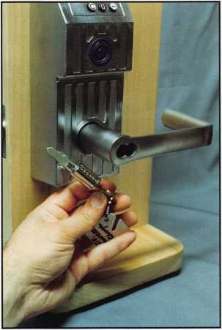

**Photo 10**

**Photo 13**

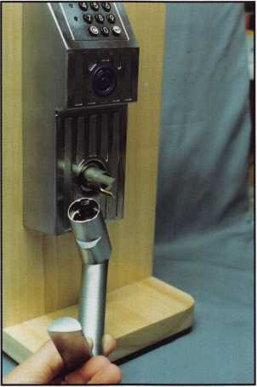

**Photo 11**

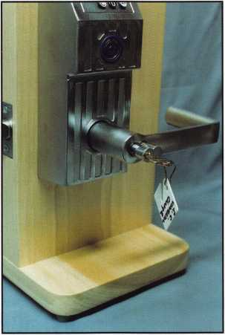

**Photo 14**

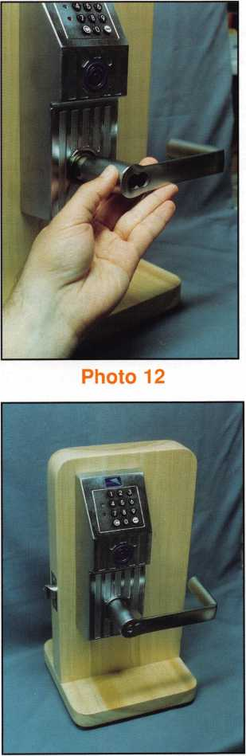

**Photo 15**

***September 2001* *Keynotes***



Institutional Locksmiths

Over the past century, Utah State University has had many different key systems supplied by lock manufacturers when new buildings were constructed or major remodels were done. The oldest building at USU, Old Main, has under­gone a couple major additions, several remodels and a few changes in locks since being built in 1888. The original locks were Yale mortise lever tumbler with bit keys. None of the original locks are in existence, though I still have a collection of the keys from those locks. In the 1930’s some Schlage locks were installed with the A-keyway. During the next 10 to 15 years, Schlage D-series locks with the E-key- way were added to Old Main. Then, in the 1950’s, all the locks were upgraded to new Schlage D-series locksets with an FG-keyway, with the exception of about a dozen locks that remained on the E-keyway. In 1982, the north wing of Old Main was damaged by fire. The next year began a 12- year, 3-phase remodel of the building, which saw the entire interior of the building replaced. In Phase One, Schlage D- series Orbit locksets with oil-rubbed bronze finish, 3 _ inch latches, and the 1456-keyway were installed. With Phase Two, we started using ASSA cylinders, and Phase Three saw a change to Sparta levers. At some point during this extended remodel, I had four different key systems in Old Main. Working at an institution is like working in a gigantic puzzle that changes frequently and tries to confuse you while testing you constantly to see if you can keep up. That is just an illustration of how key systems can change at an institution during the life cycle of a building. Sometimes things can also remain stagnant, e.g., a key sys­tem will be in a building for decades while the integrity of the system erodes away completely. Almost all institution­al locksmiths deal with this kind of situation every day, so we have to keep on our toes by mumbling to ourselves, "What are you going to do for record keeping? How do you keep it all straight so it makes sense?" "Who ya gonna call?" CODE-BUSTERS! Well, not really, because we, as institu­tional locksmiths, are responsible for the recordkeeping for our systems. When there are several key systems from

|  |  |  |
| --- | --- | --- |
| Key™ | tes | September 2001 |
|  |  | |

different lock manufacturers with each one using a code system that describes, in the manufacturers terms, some information about the key system, it can become a huge mish-mash. We have to be meticulous about the way we keep our institution’s records.

Recordkeeping for the institutional locksmith is the most important aspect of the job. Yes, we have to repair locks, install locks, specify locks for new con­struction (or we should be doing this!) and work with administrators, faculty, staff, and students. Still, updat­ing records daily while perpetually maintaining them is the single, most important part of the job. Without records, it’s just maintenance. The records should answer "Who", "What", "Where", and "When". The Keyholders are the "Who", the Keys are "What", Locations are "Where", and history is your "When", the past, present, and future of the key system.

Let me tell you about the recordkeeping dilemma with which I was faced when I took over the lockshop at Utah State University. Though you may not have had the same kind of situations I had, or perhaps your chal­lenges were tougher than I faced, I think most institu­tional locksmiths can use the principles I describe here. Just be mindful that I march to a different drum­mer - this is not the last word in good recordkeeping. In 1989, there were no records to speak of in the lock- shop at USU. There were a few key schedules from some hardware suppliers of construction projects from the previous 20 years; none of the information was in a useable, logical format. I needed to know what was out there in the way of "Who", "What", Where", and "When". I am not going to bore you with all the tedious details of how I finally got enough infor­mation together to start a database. Just know that there was an inordinate amount of time spent beating the bushes, taking a lot of legwork. My goal was to have a fully relational database where I could look up

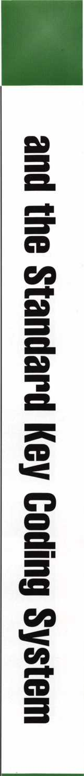

By: ROGER YOST, CIVIL, CPS

anything about keys, locations, and keyholders; check the history of these items; and, have a data entry system that was as automated as possible. My philosophy is, when it comes to computers, the fewer keystrokes, the fewer mis­takes I make.

The first step I wanted to take was to collect the raw data about the keys, consisting of bittings, keyways and brands. Then I converted this data into a format that locksmiths should know. That format is the Standard Key Coding System (SKCS), which is defined in The Professional Glossary of Terms Relating to Cylinders, Keys and Master Keying as:

n. 1. an industry standard and uniform method of desig­nating all keys and/or cylinders in a master key system. The designation automatically indicates the exact function and keying level of each key and/or cylinder in the system, usu­ally without further explanation.

(Note: Other definitions used in this article are from the same source.) Sure, I also needed to know location infor­mation, but I can do only one step at a time. Some of the original master keys were stamped with one or two letters, a key code, also known as a key symbol or key set. This is defined as:

n. a designation used for a key combination in the standard key coding system, e.g., A, AA, AA1, etc.

Schlage, Falcon and Corbin stamped their change keys with bittings. Yale did things a little differently. In the old Yale key systems, the keys were stamped with a 4-digit code so bittings were not evident. The newer Yale key sys­tems (after the mid-1980’s) had key codes stamped on the keys. Using my trusty dial caliper (I have a digital readout caliper now), I determined the bittings of the master keys and change keys where necessary and then matched the master keys with the appropriate change keys. One prob­lem I faced was having more than one manufacturer using the same key code. For example, both Schlage and Falcon have a "B" system at USU, among others. Because I will be using the key code as the primary key in my database, I cannot have different keys with the same code. Alternately, I cannot have the same key with different key codes. The key code must have a direct one-to-one relationship with the raw data of bitting, keyway and brand for each key. With 21 Top Master Keys (TMK), I created an overall plan to integrate all the different TMK’s within a single database.

Two more TMK’s from ASSA were added with the goal of replacing all 21 existing TMK’s. Today, there are only 7 of the old TMK’s left with 3 of them on the verge of extinc­tion.

When I received my first order of cylinders from ASSA for a major rekey, my paper work showed the TMK and 5 Great Grand Masters (GGM) designated by A, B, C, D and E. At USU, I have two different key systems from ASSA, one sys­tem and side bar for academic buildings, and another sys­tem and side bar for Housing and Residential Life. When I got my first order of cylinders on the second system for Housing, the TMK also was designated A. Maybe that sur­prises you, but it really didn’t come as a surprise to me. Of course, this doesn’t make sense for my database, having two completely different keys, different sidebars, and the same key code. At an institution, each key system must be viewed as part of one greater institution-wide system that includes all keys, each uniquely identified by a key code. Most locksmiths are used to dealing with smaller master key systems (under 1000 keys) so one letter would desig­nate a system. Institutional locksmiths could use the whole alphabet for all the key systems at an institution. Sometimes, thinking globally about the entire institution­wide system can cause a major headache, but it pays off in the long run. Anyway, I couldn’t use the code A for the Housing TMK - I had to select another letter, but which one? Keeping an eye on the future, the ASSA academic TMK could be further expanded to include two more GGM’s with the key codes of F and G. The next letter after G is H, so H became the key code for the Housing TMK. Coincidence, simply coincidence!

The next task was to give each of the old TMK’s a key code unique to them while preserving what little order each of the old systems had. All of the academic TMK’s were mul­tiplex key systems, which is defined as: n. 1. a series of different key sections which may be used to expand a master key system by repeating bittings on addi­tional key sections. The keys of one key section will not enter the keyway of another key section. This type of sys­tem always includes another key section that will enter more than one, or all of the keyways.

2. a keying system which uses such keyways and key sec­tions.

A good example is the Schlage Obverse key sections and

***September 2001***

***Keynotes***

keyways. The L key section will enter all the following keyways: C, CE, E, EF, F, FG, and G. See illustration 1. A key section is defined as:

n. the exact cross sectional configuration of a key blade as viewed from the bow toward the tip of the key.

A keyway is defined as:

n. 1. the opening in a lock or cylinder which is shaped to accept a key bit or blade of a proper configuration.

2. the exact cross sectional configuration of a keyway as viewed from the front. It is not necessarily the same as the key section. The academic key systems were my first priority. Housing would have to wait until later, though today Housing is almost totally changed over to ASSA with 8 buildings on TESA electronic locks. Because all of the old TMK’s were destined for elimination by design, and the key codes A through H were used for ASSA, what better place to choose the other key codes than from the end of the alphabet. Just a quirky choice on my part. The TMK key sec­tions included Schlage 1460, Schlage L, Yale GST, Falcon 6-pin R, Falcon 7-pin R and Corbin 59B2 and I gave them the key codes of Z, Y, W, V, U, and T, respectively. You can see I skipped X, since it is a special code character that indicates a "cross keyed" cylinder in SKCS. Some manufacturers, like Yale, will stamp a key

with an X prefix to the key code, but I haven’t figured out how to "cross key" a key. The Z (Schlage 1460) key section will enter 4 different keyways: 1246,1456,1467 and 1468. The correspon­ding key sections were then given the key codes ZA, ZB, ZC and ZD, respectively. See illustration 2. I kept key sections and their key codes in ascending order so there would be a similar struc­ture to all the systems - it would be easier to remember what I did.

One Schlage key system, on a 1456 key section (ZB), had key symbols from the factory of C, a Grand Master key, as the build­ing master (BM) and a series of master keys used as department masters (DM) designated CA, CB, CC, CD, etc. To convert the factory symbols to the format I am using in my database, I added the factory symbol to my key section code of ZB. Therefore, the BM is now ZBC and the DM’s are ZBCA, ZBCB, ZBCC, etc. See illustration 3. The same technique was applied to the other Schlage, Falcon and Corbin TMK’s. These three manufacturers used one key section in each key system that operated all the locks in a building, what I will call a Building Master Key System (BMKS) here for simplicity reasons. Therefore, this format worked well with Schlage, Falcon and Corbin key systems.

Yale is different, or at least the old key systems from Yale were

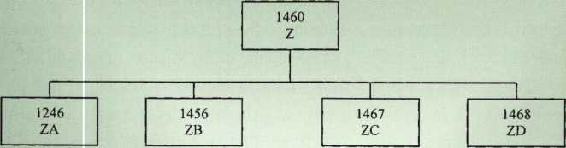

Diagram 1

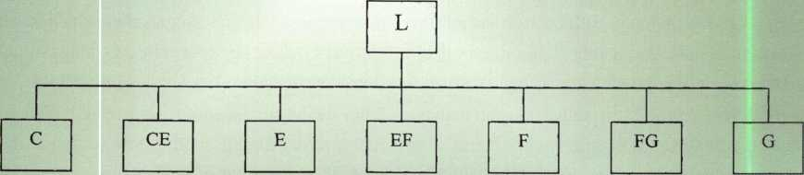

Diagram 2

Keynotes

September 2001

different. USU did have another Yale TMK on a VYZ key section. I didn’t give it a key code as this system was small, only in part of one building and it was the first academic key system I retired. The old Yale key systems consistently had several key sections under a multiplex master key for a BMKS. The key codes for the old Yale, therefore, were not as intuitively designed as the oth­ers. Yale also used the Rotating Constant method of master key­ing, something with which I was not completely familiar 12 years ago, making it enjoyable to work with Yale because I was learn­ing.

The Corbin system was just in one building with the locks having Pre-System 70 keys and cylinders, meaning the key depths went from 1 to 0 (the 0 represented a 10 depth) and the cuts were list­ed from tip to bow. All these Corbin locks had master ring cylin­ders, as well. If you’re unfamiliar with Corbin Master Ring, just know it is an elegant and remarkably beautiful cylinder design that can accommodate very large key systems. I certainly recom­mend studying this extraordinary product, to give you greater understanding of principles related to, of all things, interchange­able core cylinders. The Corbin Russwin Cylinder Manual, copy­right 1994, by Corbin Russwin Architectural Hardware, contains information about Pre-System 70, page 48, and Master Ring prod­

ucts on pages 33 through 37. Unfortunately, my predecessors at USU understood neither the depth and cuts specs (despite the bittings being stamped on the original change keys) nor the pin­ning requirements of the Master Ring cylinders, which were sab­otaged whenever a cylinder had to be rekeyed.

I have to step up on a soapbox briefly, because this is a perfect example of what happens when institutions do not have trained personnel in their lock shops. By sabotaging the Master Ring, uncontrolled cross keying became prevalent and security for the building was lost. The costs of ignorance can be devastating to lives, research and property. This should serve as a warning to institution administrators who do not understand the conse­quences of arbitrarily picking a person for a locksmith job, then not fostering the development of that person through training and education. It is obvious there are those who don’t under­stand the difference between primary security (prevention) and secondary security (intervention), the liability to which they’re exposed and what that can ultimately cost others. Congratulations to those administrators who encourage their locksmiths to be true security professionals by making vital edu­cation and training available.

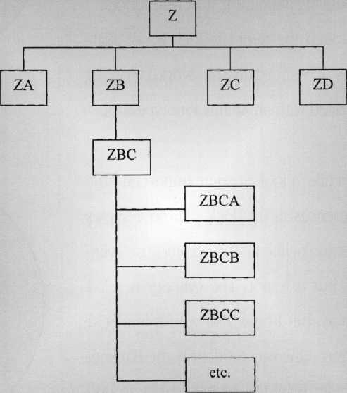

Diagram 3

***September 2001***

***Keynotes***

By David Thlelen, CML



There is a lock that looks like a standard  
Adams Rite type MS lock and cylinder,  
but it can throw you a curve if you have  
never seen one. This lock is not made by  
Adams Rite, and it’s called a Bayonet  
Lock and Cylinder. These locks are found  
in PPG aluminum storefront doors (also  
called "Pittco"). They are made by a firm  
called "Redi-Lite" somewhere overseas,  
but are unavailable through any standard  
suppliers.

PPG was a very large player in the  
Aluminum Storefront door business for  
many years, but has sold off various com-  
ponents of the company and no longer is  
producing aluminum storefront doors.  
Although the Redi-Lite lock is not avail-  
able, it can easily be worked on or  
replaced with an Adams Rite type lock.

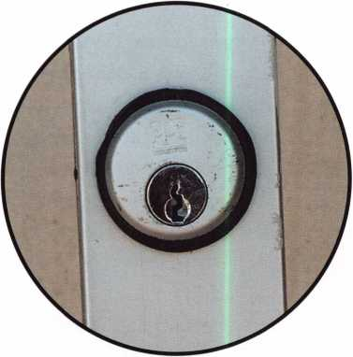

Photo 1

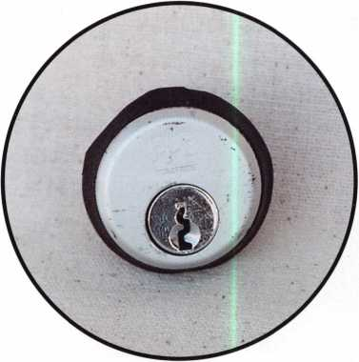

Photo 2



221

JCeynotes

Let’s take a look at some important little  
differences in this lock. Photo 1 shows  
what looks like a standard mortise cylin-  
der, but it is not. The cylinder is a Y-l  
keyway, but I have also seen it in a SC-1  
keyway. One way to identify the Bayonet  
Cylinder is by the rubber gasket around  
the cylinder instead of the traditional  
trim ring (Photo 2 and 3)

***September 2001***

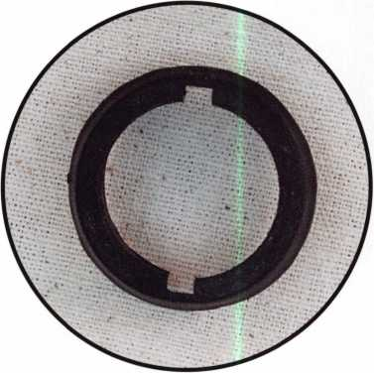

Photo 3

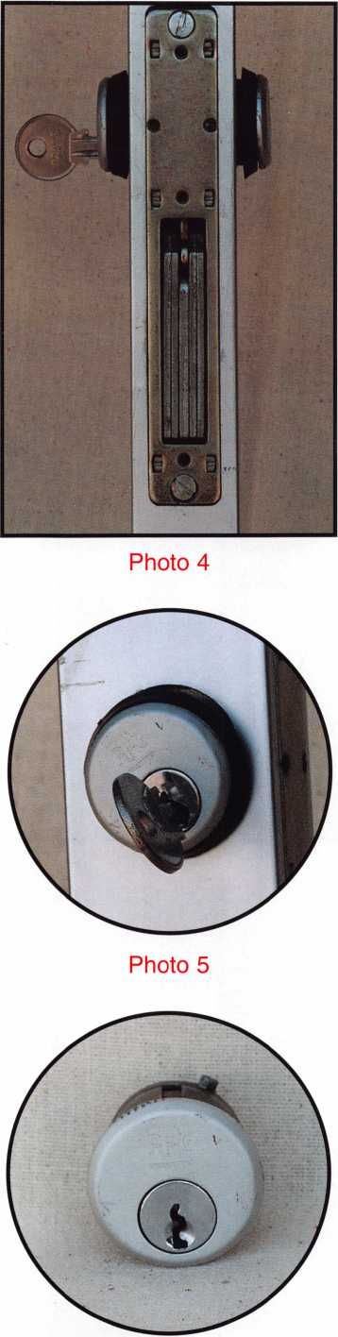

Photo 6

To remove the Bayonet cylinder, start by  
removing the three screws holding on the  
faceplate. Now we come to a slightly dif-  
ferent procedure from the normal thread-  
ed mortise cylinder. Loosen the set screw  
that holds in the cylinder (Photo 4). Turn  
the cylinder 20 degrees counterclockwise,  
wiggle it up and down and pull straight  
out (Photo 5). This cylinder does not have  
threads on it but it has two ears that hold  
it into the lock body and the rubber gas-  
ket, which keeps it snug on the door.  
Photo 6 is a front view of the cylinder with  
one of the ears shown. Photo 7 is a side  
view. Photo 8 is a rear view with standard  
A/R cam. These cylinders appear to be  
die-cast construction with loose toler-  
ances.

The cylinder can be serviced like any tra-  
ditional cylinder. To reinstall, insert it into  
the lock matching up the ears with the  
notches on the lock body, turn it 20  
degrees clockwise to straight up and  
tighten the setscrew. Replace the stan-  
dard faceplate with three screws and  
you’re done.

***September 2001***

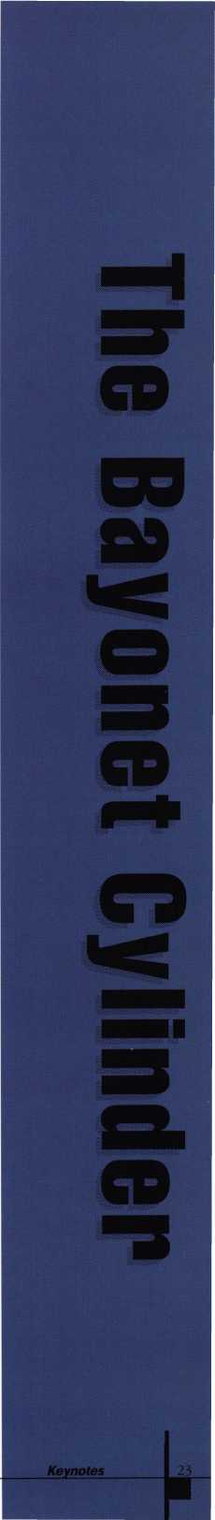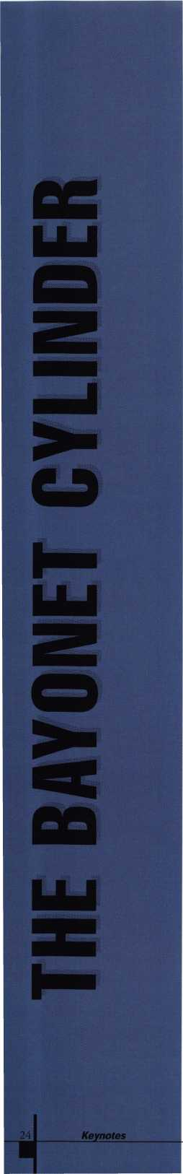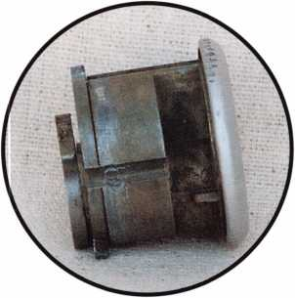

Photo 7

Although the cylinder is not threaded,  
the lock body is, permitting you to  
replace it with any standard or high secu-  
rity mortise cylinder (Photo 9). Photo 10  
shows the complete lock out of the door.  
Notice that it looks very much like an  
Adams Rite style lock, but that it has the  
notches in the cylinder area. A standard  
Adams Rite MS lock is the same size, and  
will easily replace this lock.

At first encounter, this cylinder may pose  
some problems, but do not use force.  
Simply turn it 20 degrees, wiggle and pull  
it straight out. Don’t forget the rubber  
gaskets, as they are an important part of  
servicing the lock. Often, the cylinders  
will be damaged by previous attempts to  
remove them by someone unfamiliar  
with their construction.

***September 2001***

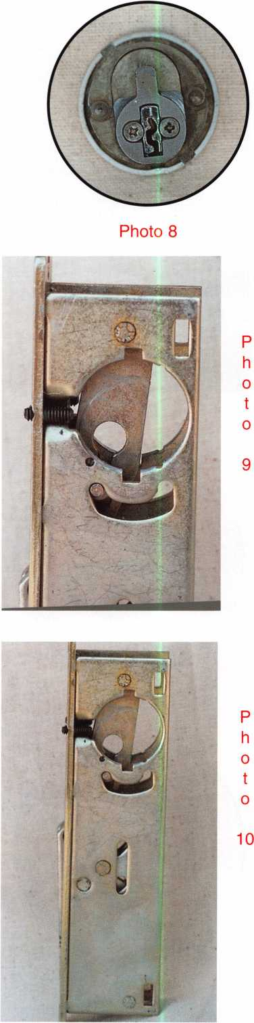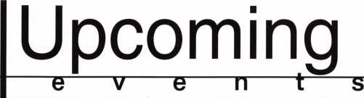

SEPTEMBER

6-9

Greater Philadelphia Locksmith Association Convention and Trade Show Philadelphia, PA 8 ACE Classes and PRP Sitting Contact: Nelson Dayton Reservation Chairman (610) 688-9188 FAX (610) 975-0172

14

«*■ ALOA PRP Sitting Dallas, TX

Contact: Ashley Manson 800/532-ALOA (2562)

FAX (214)827-1810

15

Ozark Professional Locksmith Association

Annual Distributor's Show

Inn of the Ozarks

Eureka Springs, AR

(501) 524-3660

20-22

Lou-Miss Convention and Trade Show Glen Sawyer (318) 336-5288

27-30

MINK Convention 4 ACE Classes + PRP Sitting Omaha, NE

Contact: Elmer Howard (402) 330-8701

OCTOBER

3-7

SERLAC

Education, Trade Show and Banquet

Jacksonville, FL

800/845-5294

12-14

Jo-Van Distributors, Inc.

Annual Trade and Educational Show (416) 752-2238

12

r/ ALOA PRP Sitting Dallas, TX

Contact: Ashley Manson

(214) 827-1701 FAX (214) 827-1810

15-21

rfm. Tri Regional Locksmith Conference

1. ACE Classes and PRP Sitting Portland, OR

Pacific Locksmith Association Contact: Stan Hauer (503) 325-7334 Email [hauer@pacifier.com](mailto:hauer@pacifier.com) Contact: Ken Mead (503) 873-6932

20

^ Northern Prairie Chapter of ALOA ACE Class-Combination Lock Servicing and Troubleshooting Fargo, ND

Contact: Todd Ludwig, CML (701) 232-9440

NOVEMBER

9

r/ ALOA PRP Sitting Dallas, TX

Contact: Ashley Manson 800/532-ALOA (2562)

17

f/ ALOA PRP Sitting Grand Canyon Chapter of ALOA Contact: John Ilk, CML (602) 574-5277

7-11

Yankee Security Convention 12 ACE Classes Sturbridge, MA Contact: Stephen McKinney (617) 789-3274

DECEMBER

14

t/ ALOA PRP Sitting Dallas, TX

Contact: Ashley Manson 800/532-ALOA (2562)

Indicates ALOA ACE Class r Indicates PRP Sitting

*SPEEDYP1K®*

THE AUTOMATIC  
KEY IDENTIFICATION  
SYSTEM

* Preprogrammed database with full side view
* Automatic inventory control and reorder program
* Create your own database(s) to match your keyboard
* Hire inexperienced personnel without training

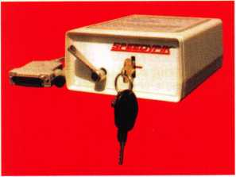

THE AUTOMATIC  
KEY DECODER SYSTEM

* Eliminates measuring each cut in a key
* Eliminates looking in pinning charts
* Portable, hand-held, battery-oper­ated
* Connects to your computer (serial port)
* Complete scan & readout in seconds

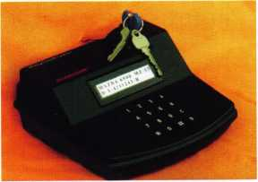

Phone: 617-567-1111  
Fax: 617-277-7777

E-Mail: SPEEDYPIK @  
AOL.COM

[www.SPEEDYPIK.com](http://www.SPEEDYPIK.com)

***September 2001* *Keynotes***

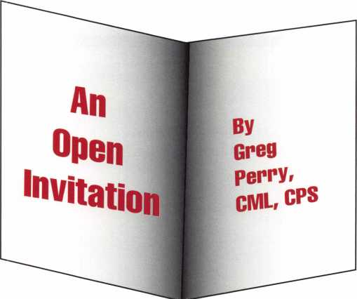

The call came in to reset a combo on a vault and rekey a couple of locks at a vacant bank building for the owner. Fortunately, he left me alone to do the work. This was the only invitation I need­ed. I immediately went out to the truck and grabbed both my digital and my 35mm camera, along with a blank technical bulletin form from SAVTA. I then took the back cover off the door and started taking pictures, dimensions and notes on the door. This is probably the best method to learn about a particular safe or vault. The best books in the world are no substitute for hands-on experience. Most customers, when asked, will allow you to take pictures. Occasionally, when I get turned down, I will draw a rough sketch and take good notes even if it’s just done in the truck after the job is com­plete. I’ll note the lock type, handing, relock locations and anything else I think is relevant.

1

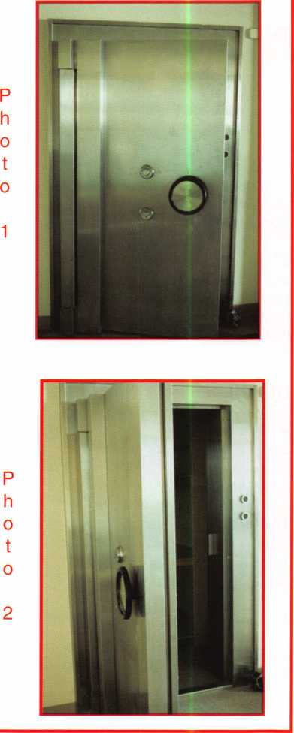

***Keynotes***

***September 2001***

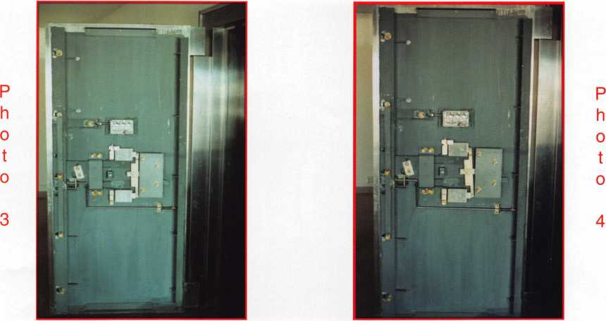

This particular vault door is a Kumahira. It was probably manufactured in 1972 since the locks are dated 1972 and the building was built about that time. Photo 1 shows us the view from the outside. We see two dials in the center of the door and a wheel to retract the bolt. From the outside of the door, we don’t know which type of lock is inside because this door has been manufactured with both vault locks and safe locks. We also do not know if this door requires both locks to be unlocked or just one before the handle will turn. In most cases, the customer will know if the door is in dual custody mode, mean­ing both locks must be unlocked or single custody, meaning either lock will open the door. This time, our customer had no clue and didn’t know either combination. Moving to the side of the door in photo 2, we see the large ll/8"X76l/2" steel locking bolt.

Photos 3 and 4 bring us inside the door. The rod that looks like a crank handle below the locks is the bolt detent rod to prevent the bolt from being extended until the door is closed. Above this rod is the bottom lock. To the right of the locks is a large steel plate covering some of the bolt works. Removing

P P  
h h  
o o  
t t  
o o

5 6

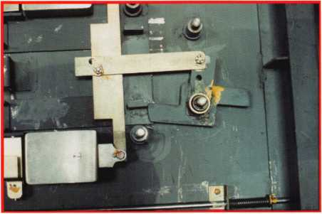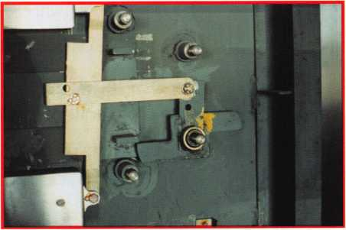

***September 2001***

***Keynotes***

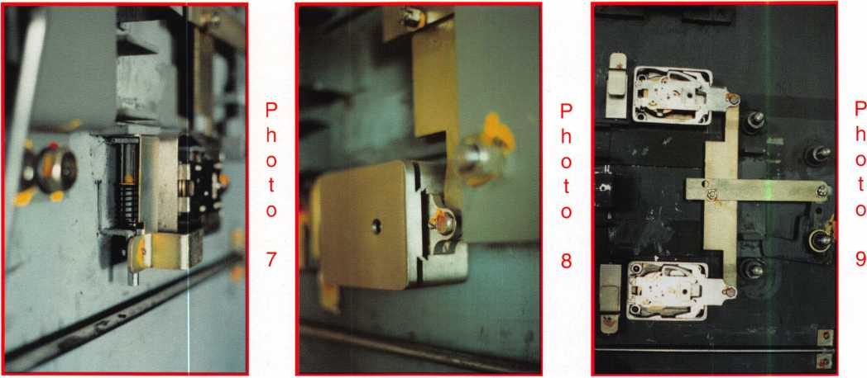

it in photo 5 exposes the locking cam in the locked position. Photo 6 shows the bottom lock unlocked and the cam is no longer blocked. A second hole in the horizontal bar is to change from single to dual custody. Installing the bar in the other hole would mean the cam would still be blocking the bolt until the top lock is opened. The external relock is shown in photo 7. The trigger arm pivots behind the lock cover to arm. Looking back at photos 3 and 4, you can see the top relock is set and the bottom relock is not.

Looking at the locks, we see they are both Sargent and Greenleaf vault locks. To look inside, we must first remove the single screw on the back and slide the back toward the bolt. The cover as seen in photo 8 has a dovetail-shaped interlock to prevent the cover from just falling off. If these locks were LOBC (locked on by combination), then the combination would have to be dialed to the changing indexes, which is about 3 or 7 o’clock, before the covers would slide. Photo 10 shows the wheel bridge assem­bly removed, each locks with four wheels. A close-up of the lock case is seen in photo 11; to the left is an uncocked relock. Lastly, we can see the time lock in photos 12 and 13. It is always important to know where the time lock is inside a safe or vault in case of a malfunction. Since there is no direct connec­tion to reference to on the outside of the door, we should take our measurements from the dial or han­dle. Some doors are supplied in different sizes, but usually the lock layout is the same.

***Keynotes***

***September 2001***

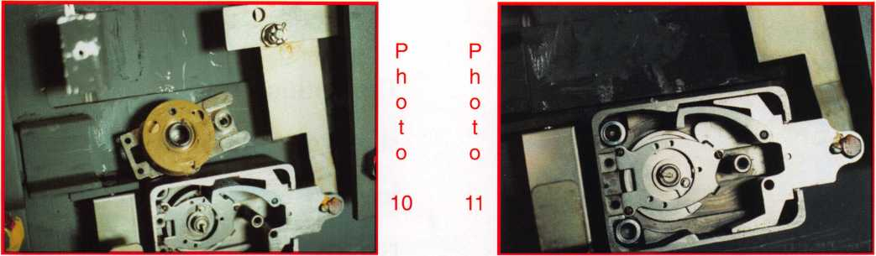

This job took me about 90 minutes to dimension and take the pictures. When I finally started looking to reset the combo, I found they were already set to 50. They didn’t need me to do anything to the vault door. I checked the numbers for them and rekeyed the place, but most of the time was spent on research. At the time, I document any safe or vault, I don’t think it is appropriate to charge for my documentation time. Instead, I look at it as an investment (just like education). The time to charge is on every job. I add a little to the routine services like a combination change and a lot when they need a safe opened. This also helps pay for the reference books I’ve purchased. For my sake, I hope they need me later. I’ll be ready.

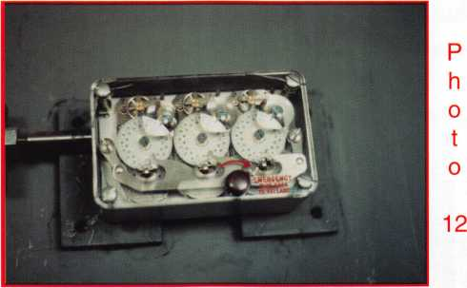

***September 2001***

***Keynotes***

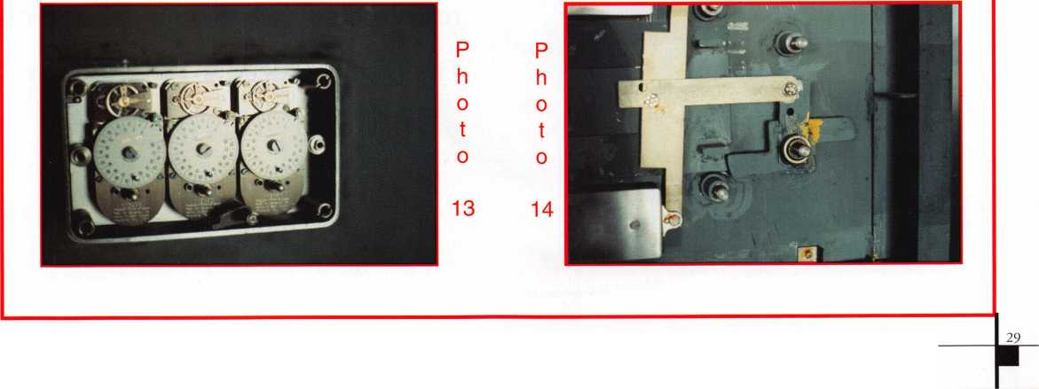

r

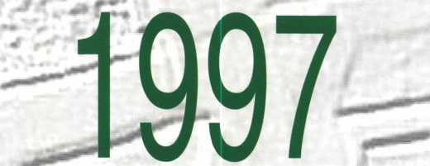

little

Accura =

The ignition housing is held on the  
steering column as most of the  
import locks are. Once you have  
removed the lock housing from the  
column, by whichever method you  
prefer, you may begin the servicing

of the cylinder. This ignition looks a

* P m .

little intimidating at first glance. (Fig

la) Especially if you are not to

ersed in the field of foreign ignition

With a little bit of inspection



By Kevin Whitesides

and a lot of care, you should have no  
problem with this lock. The face of  
the lock, which has the lighted  
assembly, actually comes off with no  
real problem as long as you don't get  
over zealous when you take it off.  
First you will need to remove the roll  
pin that holds it on. (Fig. 2)

# #i § rt'i -

J JM S *

***Keynotes***

***September 2001***

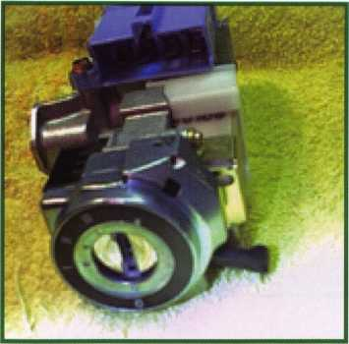

Fig. 1

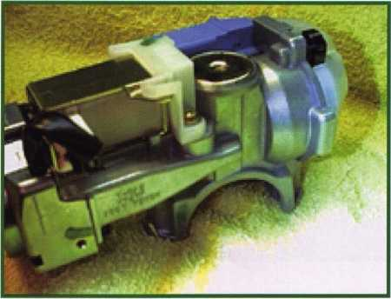

Fig. la

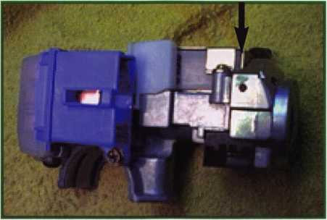

Fig. 2

Once the faceplate is off you will be able to move it out of the way so you can remove the core. (Fig. 3a & 3b)

Fig. 3a

Fig. 3b

***September 2001***

***Keynotes***

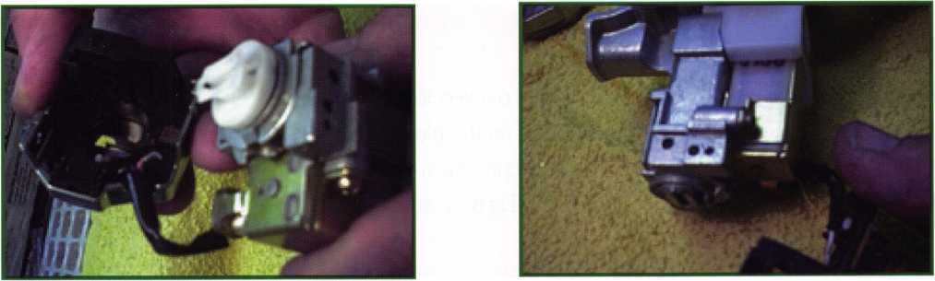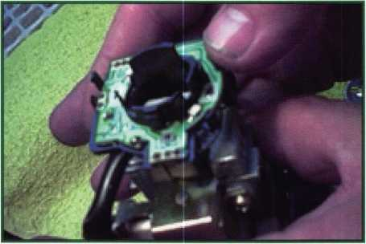

Fig. 3c

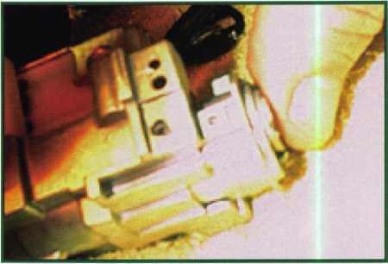

Fig. 4

Here we took the inside cover off just to see what was there. You do NOT need to take this off. (Fig. 3c)

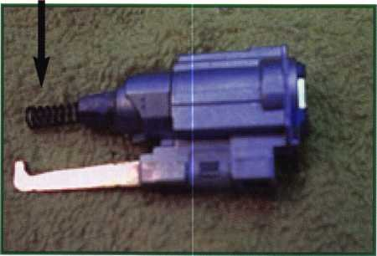

Fig. 5

Fig. 6

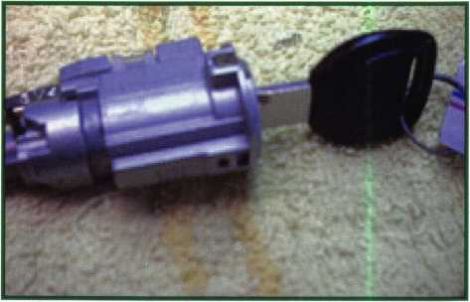

After you get the face of the lock off the plug comes out very simply by pulling it out of the housing. (Fig. 4) There is a spring in the back of the plug that pushes out on the plug. (Fig. 5) As long as you pull the core out slowly you should have no problem. Once you have the core out you will see on the back that there is a roll pin hold­ing the driver assembly onto the back of the plug. (Fig 6) You will need to punch the roll pin through so you can then remove the plug for servicing.

***Keynotes***

***September 2001***

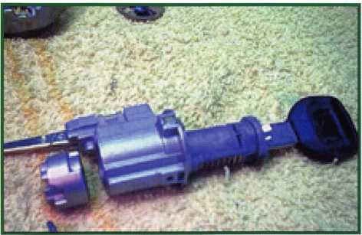

After the driving mechanism is removed, the plug comes out of the core from the front. (Fig. 7) After that you will be able to rekey or repair the cylinder as required. Once you have completed that step you will be ready to reassemble the lock.

Fig. 7



**

*tiV-UU\**

Weighs*9 in BIG!



Enjoy the new technology from ABUS!  
Using the 83 Series Pinning Window™ Cylinder!

**NEW**

• Z-Bar"

OLD

OLDER

Order the **NEW** “83/55” in any keyway from

your distributor! Receive a **FREE** ABUS ($7.99)

Trigger Lock for each # 83/55 ordered! **That'S a** SS°/o **Savings!**

Unique  
“Tear Drop”

Design

* Yale 8®
* Kwikset®
* Schlage C®
* Schlage C-L®
* Corbin®
* Sargent®
* Arrow®
* Russwin®
* Weiser - Falcon®

#83/55

order

**HURRY** while supplies last! Promotion ends - June 30, 2001

For ordering information:

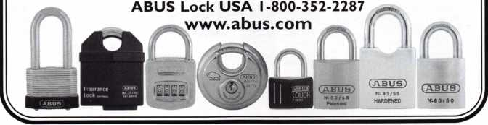

***September 2001***

***Keynotes***

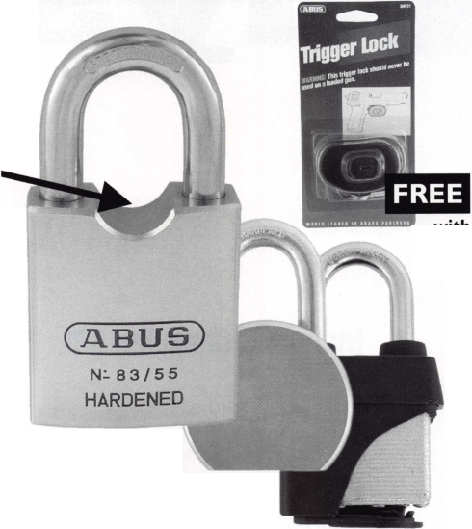

**ew**

As I write this

article, I have just  
completed my  
sixth year of  
teaching "Closed  
Circuit Television  
for Locksmiths"

at the ALOA

By Paul F. Chandler CRL convention in

Baltimore.

**earning**

***September 2001***



Interest in this subject has been steadily growing, as evidenced by the twenty-two students enrolled in the class this year.

As locksmiths, much of what we know we have figured out for ourselves. Some of us began by subscribing to a mail-order course. Others have attended locksmithing schools. Most have benefited from some personal instruction given by an employer or by a mentor. Those of us who like to read have learned a great deal from KeyNotes and the other magazines that cater to our trade, and some of us have added to our fund of knowledge by attending classes sponsored by ALOA, by local associations or by our favorite distributors and manufacturers.

ALOA has rightly earned a reputation for providing the highest quality technical instruction. The Instructor Training Course, which each ACE teacher must com­plete, provides excellent guidance in the techniques required for effective technical education. Attesting to the quality of the training are the many locksmiths who return year after year to take additional classes and fur­ther their education. For example, Clint Harding, a shop owner in the Bahamas, took a class which I taught six years ago in New Orleans. Since then, I have seen Clint attending ALOA classes every year and he usually brings one or two of his employees with him.

Having said all of this, there are many more locksmiths who do not attend classes at ALOA or anywhere else. Some of these will tell you that they would like to learn

new skills or enter new areas of the security business, but they cannot obtain that training through the avail­able classroom programs. For some, the problem is leaving their business to travel to the class venue. For some it is the expense involved. Others find that their personal learning style isn’t well served by spending 8 hours in a classroom.

Are there other methods of instruction that might make technical education available to more people? In this Information Age are there new ways to learn?

I have seen the future, and it is here. For the past two years I have been using a computer-based CCTV train­ing program as the basis for my ALOA class. The pro­gram is offered by Security Training and Marketing, and it is called STAM InSight. ALOA is an authorized dis­tributor of this CD-ROM training course, and an order form appears elsewhere in this magazine.

STAM InSight has been a tremendous teaching aid. In the past I have had to beg, borrow, and almost steal, actual CCTV components for show-and-tell in the class­room. This was a logistical nightmare and provided only moderate benefits. If we hooked the equipment up correctly we could see how it was supposed to work, but not why it worked that way. It was also impossible to simulate how it would look if it were not connected correctly and how to troubleshoot it. Since this expensive equipment did not belong to me, we were not allowed to take it apart and tinker with it.

***September 2001***

***Keynotes***

The STAM program is projected on a screen and pro­gressively explains and shows what CCTV is all about. A computer-generated voice verbalizes the main points. Supporting information is available to read on the screen. The program is interactive. Clicking on buttons causes a variety of demonstrations, video clips and com­parison images to appear that illustrate the point under consideration. If you see a word you don’t know you can usually click on it and a definition appears. Other icons link you to related topics and "thumbnail" sum­maries.

While STAM InSight has been invaluable to me in my class, the real value of the program is for self-learning. This is a complete course in CCTV, which has informa­tion for everyone from the novice to the experienced installer. For those unable to travel to distant classes, STAM brings the classroom to you. For those unable to sit and learn for hours on end, InSight can be studied in small, bite-sized portions. For those who are on a tight budget, the program can be accessed on-line, for one month, for just $145.00.

If you are seriously interested in CCTV, especially if you are a business owner with employees who will need to learn this subject, I recommend that you purchase the full "ULTIMATE" version of the program on CD-ROM. The "ULTIMATE" version includes 14 hours of instruc­tional material that you can share with everyone in your organization. It also includes a pre-test, progressive quizzes and a final knowledge assessment test. (Note: The pre-test would be an excellent screening tool if you

are ever hiring someone who claims to have CCTV knowledge.) This version also includes tools that you can use to build your CCTV business. An estimating sec­tion allows you to load in the cameras, monitors and other components you prefer to sell and then quickly use that information to produce complete, profession­al-looking quotations. A drawing section provides you with dozens of CCTV line drawings and symbols that can be used to prepare technical schematics and shop drawings. A demonstration module can be used on a laptop to show your client enough about CCTV to aid him to make a wise purchase decision (while making you look really smart, also).

STAM InSight has shown me that education can be obtained in new and effective ways. I look forward to seeing additional subject matter rendered in this excit­ing new medium.

%st a c fief away fromyour

security door hardware needs:

[www.jlmwholesale.com](http://www.jlmwholesale.com)

Website features:

Detailed product information.  
Search capabilities on each page.  
Check box to display only in stock items.  
New quick links. Extremely user friendly.  
Downloadable interactive product catalog.



charlotte, ***nc 1-800-768-6050.*** *Order On fine* **-**

[www.jlmwholesale.com](http://www.jlmwholesale.com) Qetl-ree ’Treijfit!

ADAMS RITE • ALARM LOCK • ALTRONIX - DYNALOCK • ELK • ESSEX ELECTRONICS • FOLGER ADAM SECURITY * GLYNN JOHNSON  
H.E.S. • I.E.I. • LCN CLOSERS • LOCKNETICS SECURITY ENGINEERING, INC. • ROTON • SCHLAGE • SECURAKEY * SECURITRON  
SECURITY DOOR CONTROLS • SELECT PRODUCTS • SIMPLEX • SIGNAL CABLE • TRIMEC • TRINE • VON DUPRIN

***Keynotes***

***September 2001***

Adesco Guest Safe Series 2

The Adesco Guest Safe is designed for hotels, college dorm rooms, or any application where temporary storage is a necessity. The GS-5E-LTB unit is equipped with an easy-to-use electron­ic lock, while the GS-5EC operates with the swipe of a credit card.

GS Standard Features:

Solid steel construction  
Master override key Pre-drilled bolt  
holes for simple installation (bolt  
included) Hand-felted false bottom  
hides anchor holes, Multi-language  
guest instructions, Attractive two-tone  
epoxy-based paint finish.

PRICE USl

A c*w&m (*mk m mat* priAm* xt

MAG StasKity .tesAam

MAG Security is well known as the inventor and manufacturer of the Install-A-Lock door security plates. Today we provide over 600 items of door and window security products including M.A.G. Install-A-Locks, latch Guards, Filler Plates, specialty Strikes and numerous auxiliary win­dow & patio door items.

M.A.G. Engineering

15261 Assembly Lane  
Hunting Beach, CA 92649

(P) 800-624-9942  
(F) 714-892-6845

CCL Security Products

CCL Security Products is proud to introduce the K440 Sesamee padlock. The K440 has a four- inch shackle, which gives you the largest clearance out of any Sesamee on the market today. Remember, when looking for the best quality in cam, desk, cabinet, or drawer locks look no further than CCL.

CCL Security Products

199 Whiting Street  
New Britain, CT 06051

860.339.6199  
FAX 860.223.7601

[www.cclsecurity.com](http://www.cclsecurity.com)

***September 2001***

***Keynotes***

ABUS Lock Co.

ABUS is pleased to introduce it's new product specification and price book which features over 200 new products and accessories for the locksmith mar­ket. The ABUS motorcycle lock line is also featured which includes chains, locking cables, brake disk locks and cut resistant U-Locks.

Featured product:The Heavyweight Padlock series. Don't miss out on these heavy duty locks.

For more information on the ABUS  
Padlock Line please call:  
1-800-352-2287

QUICK-OUT

Aable Locksmith 86-19 97th Avenue Ozone Park, NY 11417

718.847.1377 FAX 718.847.0991

QUICK-OUT

Fits virtually all model autos. Easy to install. A child can release the trunk latch from inside the trunk to escape. Federal Law on new vehicles. A must for all others. This is probably the most important device in this catalog. Window posters and mounted locks avail­able.

(ABUS)

N-83/55

**hardened**

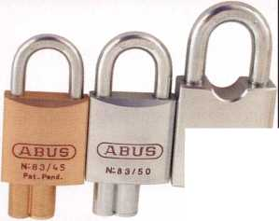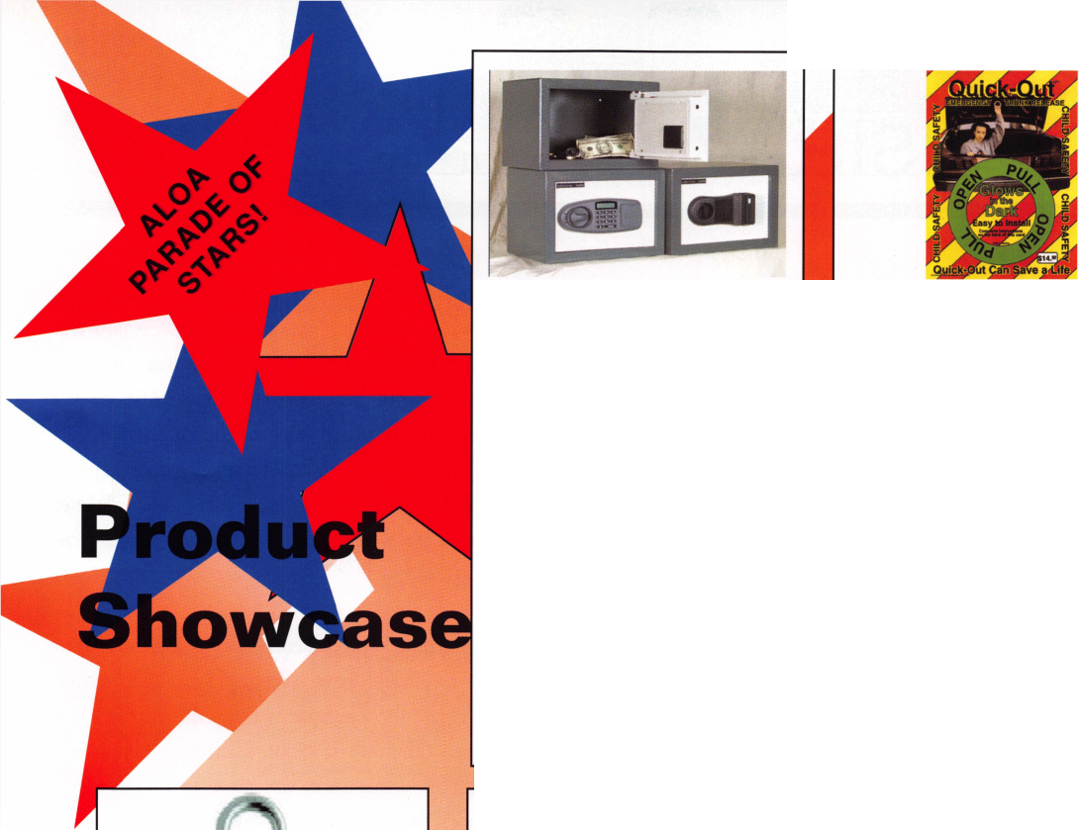

CONVENTION LEGISLATIVE RECAP  
LOCKSMITHS EXCHANGE IDEAS, TLA AND NCLA  
RECEIVE AWARDS, BOARD APPROVES ALOA  
BECOMING MORE PRO-ACTIVE

To say the Baltimore convention was a success for the Government Affairs department is putting it mildly.

The ALOA Government Affairs booth not only had the popcorn machine serving up fresh hot buttered popcorn but also infor­mation on all bills, and legislation in attendee's home state. You could even go online and send an email to your state Representative, Senator or Governor! We signed up a number of new Legislative Action Network (LAN) members bringing the total to over 450!

The State-of-the-States Roundtable was the largest to date with over 30 people in attendance, including representatives from the Allied Locksmiths of Illinois; Associated Locksmiths of Ireland; California Locksmith Association; Clearstar Network; Fox Valley Chapter (Wisconsin); Greater Philadelphia Locksmith Association; Indianhead Chapter (Wisconsin); Japan Chapter; Keystone Chapter (Pennsylvania); Korea Chapter; Locksmith Security Association of Michigan; Louisiana-Mississippi Locksmith Association; Maryland Locksmith Association/Chesapeake Chapter; Master Locksmith Association of New Jersey; National Burglar and Fire Alarm Association; National Locksmith Association of Canada; North Jersey Master Locksmith Association; Ohio Locksmith Association; Penn-Ohio Locksmith Association; Pine Tree State Locksmith Association (Maine); Southern New Jersey Locksmith Association; Tennessee Organization of Locksmiths; Texas Locksmith Association; Virginia Locksmith Association and a number of ALOA Board members. This meeting proved to be a great way to exchange information and ideas including Korea's and Irelands efforts at licensing for their respective countries, Tennessee thanking

**38J*KeynotesSeptember 2001***

GPLA for coming down to help them strategize, Illinois reporting that their law will go through a Sunset Review process next year, an NBFAA representative letting everyone know that it was their national policy to work with locksmiths on legislation, New Jersey reported they are still working on their licensing regula­tions, Virginia reported that they are encouraging their members who do access control to get an alarm license, and Canada offer­ing to put news items of other associations in their news­magazine.

The Legislative Action Network Reception was a great time for LAN members to unwind, have some good food and refresh­ments and celebrate the legislative victories this year in Texas, North Carolina, Connecticut, South Carolina, Illinois and Oregon. A special presentation was made to the Legislative Action Network's Organization of the Year, Texas Locksmith Association recognizing their hard work in getting a locksmith registration bill passed and defeating the Texas Alarm Association on harmful legislation and the North Carolina Locksmith Association for their work on the locksmith licensing bill (see below).

In an historic move, the ALOA Board decided it was time for ALOA to become more proactive when it came to licensing legis­lation. For a number of years, ALOA has maintained the position that locksmiths should be licensed. For this reason ALOA devel­oped a "Model Law" to assist the locksmiths of a state that might pursue licensing. ALOA has assisted state licensing efforts when such assistance has been requested. However, the Board felt that as long as the alarm association and other low-voltage industries continued to introduce alarm licensing bills or attempts to mod­ify existing laws to encompass access control, or regulation of the low-voltage industry, locksmiths would forever be on the defen­sive. Therefore, the Board adopted the following public policy statement: "ALOA will take a proactive role in the passing of lock-

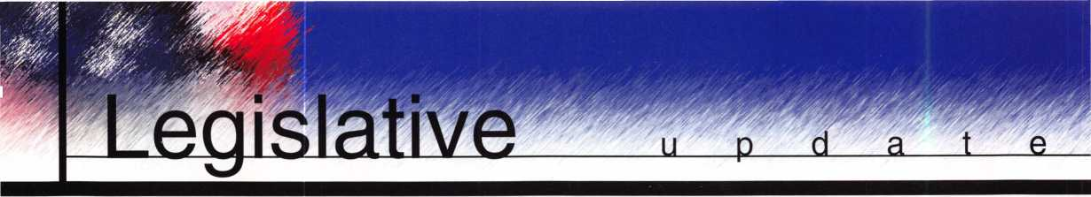

smith licensing." The Board's reasoning to become more proactive was that licensing helps secure locksmiths from future attacks from the alarm industry as well as other related factions, it eliminates the cost of continually fighting alarm and other licensing legislation, and defines locksmithing under the law. It also pro­tects the public from unqualified persons or criminals practicing as locksmiths and raises the standards of professionalism within the industry and promotes a certain amount of prestige and community status. It ensures that locksmiths are to keep up-to-date on new techniques with­in the industry, through continued education and testing, and competency requirements, and helps reduce liability by requiring customer ID when providing access. How this will be implemented will be worked on over the com­ing months, but if your state is interested in licensing, ALOA will now have the resources to help!

THIS JUST IN...Through years of hard work and determination, committed ALOA members, the North Carolina Locksmith Association and the Government Affairs Department at ALOA a fair and equitable locksmith licensing law has been passed in North Carolina! Check out [www.aloa.org/news/legislation.cfm](http://www.aloa.org/news/legislation.cfm) for the lat­est version of this bill, and the October issue of Keynotes for the full story!

MasterLink Security Products

ROGER ALEXANDER-TUTTLE

“...understanding the needs of locksmiths...”

Mortise/Rim/Knob Cylinders • Storefront Door Hardware  
Cabinet Locks • Chain • Key Blanks • Padlocks • Pins ...and more

Local: (954) 730.9669 • Toll Free: (877) 347.9669  
Fax: (954) 486.0575

e-mail: [masterlink@mindspring.com](mailto:masterlink@mindspring.com)

3863 NW 19th Street, Lauderdale Lakes, FL 33311

Its True

Marray has developed the first  
screwless door loop.

Aluminum ma-  
terial means  
true anodizing.

No off color  
powder coat-  
ing or painting

Screwless base and cap means you drill two 1/2 inch diameter holes, pop the base into the hole, wire your system and snap on your covers. Simple as 1, 2, 3.

**Here’s the best part We are giving away a**

FREE SAMPLE TO THE FIRST **10O** CALLERS WHO MEN-  
TION THIS ADD. **A $14.40** WHOLESALE PRICE VALUE.

CALL TODAY, IT’S FREE!!

1-800-500-1449

Marray *enterprises, inc.*

At Marray, we’re not just modifiers, we’re Master Hardware Modifiers™  
1128 Walsh Ave., Santa Clara, CA 95050* [www.marray.com](http://www.marray.com)

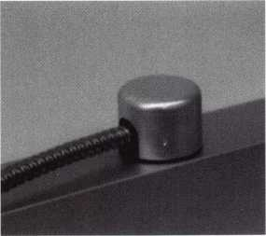

Standard 18” length. Can be ordered in cus­tom lengths

Plastic base stops shorts and pro­tects wires

***September 2001***

***Keynotes***

Service Tech Wanted

Long Beach, CA. area experienced in all  
phasis required. Camera Technician a big  
plus!

Call Jack at (562) 597-8888

Safemasters

A nationwide industry leader, ha?

opportunities

available for experienced technicians  
knowledgeable in any §§pl following  
specialties: Accesssj^pifd, CCTV, Safes,  
or General Locksmithing. As an  
innovative Family Friendly employer our  
employees enjoy flexible scheduling,  
401(k) and company match, health, dental

and vision insurance, Long arid4?

apany

5l|t

Jll¥,

Short Term disability insurance, %  
vehicles, opportunities for

advancement, company paid training prt

grams, technical skills updates, new prod-  
uct training, trade schools and college  
courses, generous leave programs, etc.  
We are committed to our associates and  
their families as we stand side by side in  
sharing the rewards of hard work and cus-  
tomer friendly professional service, with  
all our associates. Our team effort makes  
Safemasters an enjoyable career experi-  
ence which provides many opportunities  
to advance your career, your skills, your  
personal life. We hold our associates in  
the highest esteem because we know they  
are the best in the industry and take pride  
in a job well done. It is through this dedi-  
cation and loyalty that we continue to  
grow and expand offering all associates  
the stability of a company with over 60  
years of experience, a committed team of

support personnel to assist you in doing  
what you do best and a realistic approach  
to balancing your work and home life. We  
have locations in Maryland, Virginia,  
Wilmjjj|fe (DE), Philadelphia,  
**PidgB**trgh, Boston, New Jersey,

anapolis, and Chicago. Stop by one of

our offices and talk to the manager about  
your needs and how we can fill them or  
mail to our Headquarters at:

Safemasters, 2700 Garfield Avenue, Suite  
200, Silver Spring, MD 20910, to the  
attention of Human Resources or email us  
[athr@safemasters.com](mailto:athr@safemasters.com).

Wanted Sales Superstar

Here We Grow Again! Bass Security  
Services, Inc. is looking for the best of the  
best. If you are an experienced, motivated,  
and no-nonsense sales professional with

an extensive background in the security

.dustry, we want YOU! All candidates

must have a minimum of 7 years in the  
locksmith / security field, with a back-  
ground inlsales and customer service. We  
offer: Top wages with excellent incentives,  
401k, paid vacatiblyind holidays, health  
benefits, and continuidjndustry educa-

tion. Re-location assistanc§4|ay be provid-

Contact:

Bass Security Services, Inc.

Ph#216-755-1200 Ext# 128  
Fax#216-755-1220

e-mailV [rmesnick@bass-security.com](mailto:rmesnick@bass-security.com)

Experienced Locksmith  
Wanted

Las Vegas-based company that deals with  
all phases of surveillance, access control  
and locksmithing is looking for a highly



qualified and motivated individual to per- form locksmith duties. Vegas Valley Locking Systems Inc. has an established customer base and is expanding. Qualified individuals will have extensive experience 4 in locksmithing, safes, and door hafdware. Electronic hardware experienced^ plus. Great benefits. Salary DOE.Please call and/or fax resume to: *

James Rochester 6207 Industrial Road Las Vegas, NV 89118 702/614-3939 702/614-8052 (fax)

Locksmith Wanted

Looking for serious, dedicated profession­als to make at least $50K/year. Come to the cool Gulf shores of Houston, TX. Home for all the great fishing, sun and fun you can stand. Home of low payroll taxes, low cost living and the good life. Great job opportunity for the right person. Offering fantastic pay, paid vacation and holidays, great bonus program and growth oppor­tunity in CCTV and alarms. Professional people with tools and vehicles.

Call 281/830-9441 or fax 713/266-4350.

Experienced Locksmith

Growing, established 22-year company is  
seeking lead locksmiths. Experience  
required in commercial locksmithing,  
including safe work and electronic  
access,CCTV, panic hardware, master key  
systems; Wprk in and around the nation’s  
Capitol. Excellent opportunity for individ-  
ual dedicated itijhe trade and to cus-  
tomer service. Company provides vehicle,

tools and uniforms. Salify.,commensurate

***Keynotes***

***September 2001***



with experience. Paid holidays, vacations, health insurance and 401(k). Please fax resume to 301/424-3080 or call toll free 888/424-LOCK (5625).

Locksmith for Hire

Northern New Jersey Locksmith looking for employment with quality company. Experience with most hardware including Medeco.

Jim Nasta at973/815-1627.

■WANTED TO BUY/SELL

For Sale

100-ACE Realtor, over the door lock boxes. All keyed alike - only $3 each. Call, Key Hole at 806/352-2157. Weekdays only, 8:30 a.m. to 5:30p.m.

Wanted: Auto Key Blanks

Wanted - old auto key blanks, Hurd, Briggs & Stratton, Yale. Will pay $1 each. Douglas Vogel, 4779 Meadowlark Lane, Dexter, MI, 48130.

For Sale

Buy things you need from my inventory and save 30 percent off wholesale.

Call the Post Key Co toll free at 888/949- *7089****.***

■BUSINESSES FOR SALE

Business for Sale

Mobile locksmith business for sale, retir­ing, established 15 years. Western Maryland year-round resort area. Lake and ski resort nearby. Fast-growing area. Only full-time locksmith in area.

Call 301/387-6026.

For Sale

Established locksmith business for sale in Pembroke Pine, FL. Same location since 1972. The store comes with equipment, two vans and residential and commercial accounts. Grosses over $100K per year. Serious inquiries only. Please contact Peter at954/962-4535.

Business Opportunity

Associated Locksmith Network, Corp. is looking to subcontract locksmith compa­nies around the nation and in the Caribbean. If interested, request an appli­cation now at New Accounts (AL0100) atP.O. Box 771296, Miami, FL

33177-9998

**Classified  
Advertising Policy**

Classified advertising space is provid­ed free of charge to ALOA members, and for a fee of $.60 per word, $15 minimum for non-members. Classified ads may be used to adver­tise used merchandise and over­stocked items for sale, “wanted to buy” items, business opportunities, employment opportunities/positions wanted and the like. Members or non-members wishing to advertise services or new merchandise for sale may purchase a “Commercial Classified Ad,” for a fee of $1.30 per word, with a minimum of $40. Each ad will run for two issues. For blind boxes there is a $5 charge to mem­bers and non-members. All ads must be submitted in writing to the ALOA office by the fifteenth of the month, two months prior to issue date. Send to Keynotes Classifieds, 3003 Live Oak St., Dallas TX 75204-6186. ALOA reserves the right to refuse any classi­fied advertisement that it deems inappropriate according to the stated purpose of the classified advertising section.

***September 2001* *Keynotes***

AM INDUSTRY TRADITION

yankee

Security

Conference

jfovember 7-11,2001

STURBRIDGE HOST HOTEL, STURBRIDGE, MA

* 10 comprehensive and innovative classes
* ALOA, A.C.E. certified instructors
* The industry’s top manufacturers, distributors and manufacturers' representatives



TO SHCU^JTY

Visit us at [www.yankeesecurity.org](http://www.yankeesecurity.org)

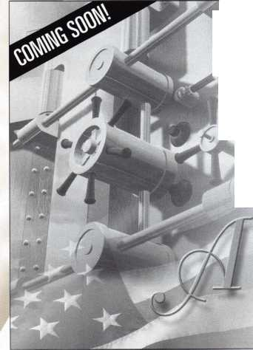

members

MANUFACTURERS

•A & B Safe Corp.

(800) 253-1267 FAX (856) 863-1208

•Abloy Door Security

(514) 335-9500 FAX (514) 335-0430

•Adams Rite Manufacturing Co.

(800) 872-3267 FAX (800) 232-7329

•Adesco Safe Manufacturing Co.

web: [www.adesco.com](http://www.adesco.com) (800) 821-6803 FAX (562) 408-6427

•Adrian Steel Company

web: [www.adriansteel.com](http://www.adriansteel.com) (800) 677-2726 FAX (517) 265-5834

•Alarm Lock Systems, Inc.

(800) ALA-LOCK (516) 789-3383

•American Lock Co.

(708) 534-2000 FAX (708) 534-0531

•American Security Products (AMSEC) (800) 423-1881 FAX (909)685-9685

•Baldwin Hardware Corp.

(610) 796-4012 FAX (610) 796-4493

•Buddy Products

(800) 886-8688 FAX (312) 733-8356

•BWD Automotive

(334) 872-6524 FAX (334) 874-6011

•COMPX Security Products

864/297-6655

864/297-9987

•Curtis Industries

FAX (800) 867-6020

•DETEX Corporation

800/729-3839 830/620-6711

•DORMA Architectural Hardware

717/336-3881

717/336-3500

•Don-Jo Manufacturing, Inc.

978/422-3213

978/422-3467

•Doyle Security Products

800/333-6953

612/521-0166

•DSC Group of Companies

(905) 760-3000 ext. 2200 FAX (905) 760-3040

•Door Controls International

(800) 742-3634 FAX (800) 742-0410

•ESP Lock Products, Inc.

(978) 537-6121 FAX (978) 534-9109

•Ewert Wholesale Hardware

800/451-0200

708-597-0881

•Fairway Supply, Inc.

214/350-0021

214/352-4299

•H.L. Flake Co.

•HES, Inc.

623/582-4626

623/582-4641

•Hardware Agencies, Ltd.

(416) 462-1921

•Hongtai Lock Co Ltd.

137-238-1414 FAX 208-793-3856

•HPC, Inc.

(847)671-6280 FAX (847) 671-6343

•Ilco Unican

(252) 446-3321 FAX (252) 446-4702

•Intellikey

(800) 226-0703 FAX (407) 724-0811

•Jensen Tools Inc.

(602) 453-3169 FAX (602) 438-1690

•Jet Hardware Mfg. Co

(718) 257-9600 FAX (718) 257-0973

•KABA High Security Locks

(860) 621-3601 FAX (860) 621-9727

•KEY-BAK; Div. of W. Coast Chain Mfg.

(909) 923-7800 FAX (909) 923-0024

•Knaack Manufacturing Co.

(800) 456-7865 FAX (815) 459-9097

•LAB Security

(800) 243-8242 FAX (203) 583-7838

•LCN Closers (Division of Ingersol)

(815) 875-3311 FAX (815) 879-1497

•La Gard, Inc.

(310) 325-5670 FAX (310)325-5615

•Lucky Line Products

(619) 549-6699 FAX (619) 549-0949

•Locksmith Ledger International

(770) 886-0800 FAX (770) 889-7703

•M.A.G. Engineering & Mfg. Inc.

(714) 891-5100 FAX (714) 892-6845

•MARKS USA

(516) 225-5400 FAX (516) 225-6136

•MARRAY ENTERPRISES

(408) 970-0213; FAX (408) 970-8767

•Master Lock Company

(414) 444-2800 FAX (414) 449-3114

•Medeco Security Locks

(540)380-5000

FAX (540) 380-5010

•Meilink Safe Company

(800) 634-5465 FAX (800) 896-6606

•MMD Inc.

(865) 428-3611 FAX (865) 453-4136

•MCS Communication Systems

(514) 444-2040 FAX (514) 444-2029

•Massglass & Door Service

(888) 742-8837 FAX (818) 991-5742

•Monaco Lock Co.

(800) 526-6094 FAX (800) 845-5625

•Mul-T-Lock USA, Inc,

(800) 562-3511 FAX (973) 778-4007

•ROFU International Corp.

(800) 255-7638 FAX (253) 922-1728

•Rutherford Controls Int’l. Corp.

(757) 427-1230 FAX (757) 427-9549

•STRATTEC Security Corp.

(414) 247-3333 FAX (414) 247-3329

•Sargent & Greenleaf, Inc.

(606) 885-9411 FAX (606) 887-3063

•Sargent Manufacturing

(203) 562-2151 FAX (203) 776-5992

•Schlage Lock Co.

(800) 847-1864 FAX (800) 452-0663



***Keynotes***

***September 2001***

•Schwab Corporation

(765) 447-9470 FAX (765) 447-8278

•Securitron Magnalock Corp.

(800) 624-5625 FAX (775) 355-5636

•Security Door Controls

(805) 494-0622 FAX (805) 494-8861

•Security Solutions

(405) 376-1600 FAX (405) 376-6870

•Sentry Group

(716) 381-4900 FAX (716)381-8559

•Somerset Security Products

(800) 881-5206 FAX (800) 206-9949

•Sully Tools Inc.

(703) 689-3416 FAX (703) 787-0869

•Sun-IL Gum Go

823-194-59300 FAX 823-194-59400

•Taymor Industries, Inc.

(800) 388-9887 FAX (800) 288-8133

•The National Locksmith

630/837-2044

630/837-1210

•Trine Products Corporation

(718) 829-2332 FAX (718) 829-6405

•Videx, Inc.

(541) 758-0521 FAX (541)752-5285

•W-Lok Corporation

(616) 355-4015 FAX (616) 355-4295

•Yale Security Inc.

(800) 438-1951 FAX (800) 338-0965

DISTRIBUTORS

•Accredited Lock Supply Co.

(800) 652-2835 FAX (201) 865-5031

•Ace Lock & Security Supply Co.

(800) ACE-LOCK (800) ACE-FAX4

•ADI

(516) 692-1000 FAX (516) 692-3457

•Andrews Wholesale Lock Supply

(717) 272-7422 FAX (717) 274-8659

•Boyle & Chase Inc.

(800) 325-2530 FAX (800) 205-3500

•Clark Security Products, Inc.

(800) 854-2088 FAX (619) 974-5284

•Cook’s Building Specialties

(505) 883-5701 FAX (505) 883-5704

•Dire’s Lock & Key Co.

(303) 294-0176 FAX (303) 294-0198

•Direct Security Supply, Inc.

(800) 252-5757 FAX (800) 452-8600

•Doyle Security Products

(800) 333-6953 FAX (612) 521-0166

•Dugmore & Duncan Inc.

(888) 384-6673 FAX (888) 329-3846

•E. L. Reinhardt Co., Inc.

(800) 328-1311 FAX (612) 481-0166

•Foley-Belsaw Company

(800) 821-3452 FAX (816) 483-5010

•Fried Brothers, Inc.

(800) 523-2924 FAX (800) 541-3489

•HS&S Wholesale Distributors

1(800) 521-2202 FAX (313) 342-7580

•Hans Johnsen Company

(214) 879-1550 FAX (214) 879-1530

•Howard Keys

(704) 509-4944 FAX (704) 509-6248

•IDN, Inc.

(817) 421-5470 FAX (817) 421-5468

•Intermountain Lock & Supply Co

(800) 453-5386 FAX (801) 485-7205

•Jo-Van Distributors Inc.

(416) 752-7249 FAX (416) 752-3845

•Lockmasters, Inc.

(800) 654-0637 FAX (859) 885-7093

•Locks Company

(800) 288-0801 FAX (305) 949-3619

•The Locksmith Store Inc.

(847) 364-5111 FAX (847) 364-5125

•M. Zion Company

(212) 349-8677 FAX (212) 964-0495

•McDonald-DASH Locksmith Supply

(800) 238-7541 FAX (901) 366-0005

•McManus Locksmith Supply, Inc.

(702) 333-9112 FAX (704) 332-8664

•Marray Enterprises

(408) 970-0213 FAX (408) 970-8767

•Omaha Wholesale Hardware

(800) 238-4566 FAX (402) 444-1644

•Securite.com

(800) 241-3930 FAX (858) 974-5269

•Sentry Security Fasteners

(309) 693-2800 FAX (309) 693-2872

•Southern Lock and Supply Co.

(800) 237-2875 FAX: (800) 447-2299

•Stone & Berg Wholesale

(800) 225-7405 FAX (800) 535-5625

•Strauss Safe & Lock Company

(515) 276-7030 FAX: (515)276-7031

•Taylor Securtiy & Lock Co.

(301) 948-7670 FAX (301) 948-1029

•Timemaster, Inc.

(800) 798-8464 FAX (800) 798-8463

•Top Notch Distributors, Inc.

(800) 722-4210 FAX (800) 248-3620

•U.S. Lock Corporation

(800) 925-5000 FAX (800) 338-5625

•Webster Safe & Lock Company, Inc.

(901) 332-2911 FAX (901) 332-2878

SERVICE

•Allstate Insurance Company

(847) 402-8196 FAX (847) 326-7509

***September 2001***

***Keynotes***

About the Authors

AD INDEX

*Paul F. Chandler, CRL*

***manages the electronic security products division  
of l.D.N. -Acme. Paul earned his journeyman  
electrician license in Massachusetts in 1983, and  
passed the PRP in 1987. He has experience in  
CCTV, alarms access control systems, high securi-  
ty locks and safes. Paul has written for several***

***trade magazines and was the Keynotes Author of the Year for  
1998. Paul’s classes on access control and basic electricity have  
been enjoyed by locksmiths throughout the southwest.***

*Claire Cohen*

***the second woman to become a CML, has been in locksmithing since 1977 and has been writing articles for Keynotes since 1987. She is also a con­tributing editor for Keynotes, and was just named the 2001 Keynotes Author of the Year - again, the second woman to achieve that honor.***

|  |  |
| --- | --- |
| SpeedyPik, Inc | 25 |
| Abus | 33 |
| JLM Wholesale | 36 |
| MasterLink  Security Products | 39 |
| Marray Enterprises | 39 |
| Yankee Security | 41 |
| HICKOK Inc. | BC |

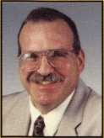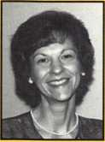

*Sal Dulcamaro, CML*

***has been in the security industry for over 26  
years. He is the president of All Pro Security, Inc.  
in Michigan and has been an ALOA member for  
19 years. A past president of the Locksmith  
Security Association of Michigan, Sal currently  
serves as editor of the association newsletter. He***

***was named Keynotes "Author of the Year" in both 1996 and  
1997. He is also a contributing editor for Keynotes. Find Sal on  
the Internet at: <http://www>. home, earthlink. net/- lockwriter.***

*Greg Perry, CML, CPS*

***has been in the locksmith industry for 18 years. He's spend half of that time as a field technician for Security Engineering in Ridgecrest, Calif. Greg is also a past president of the Desert Counties Chapter of the California Locksmiths Association.***

David E. Thielen, CML

is the lockshop manager for Adams Twelve Five Star School District, Broomfield, Colorado. He has been a professional lock­smith for more than 15 years a member of RMLA and DHI and a member ofALOA since 1985. He has instructed classes for the Rocky Mountain Locksmiths Association and has developed and instructed ACE certified classes for ALOA at regional and nation­al conventions.

Kevin Whitesides

helps manage and operate Liberty Lock and Safe in Las Vegas, NV.

Roger Yost, CML, CPS

heads up the lock department at Utah State University in Logan, UT.

9K H

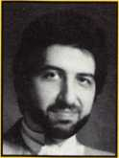

***Keynotes* *September 2001***

**Rock**

John Ascuaga's Nugget Resort

e s

***September 2001***

***Keynotes***

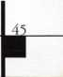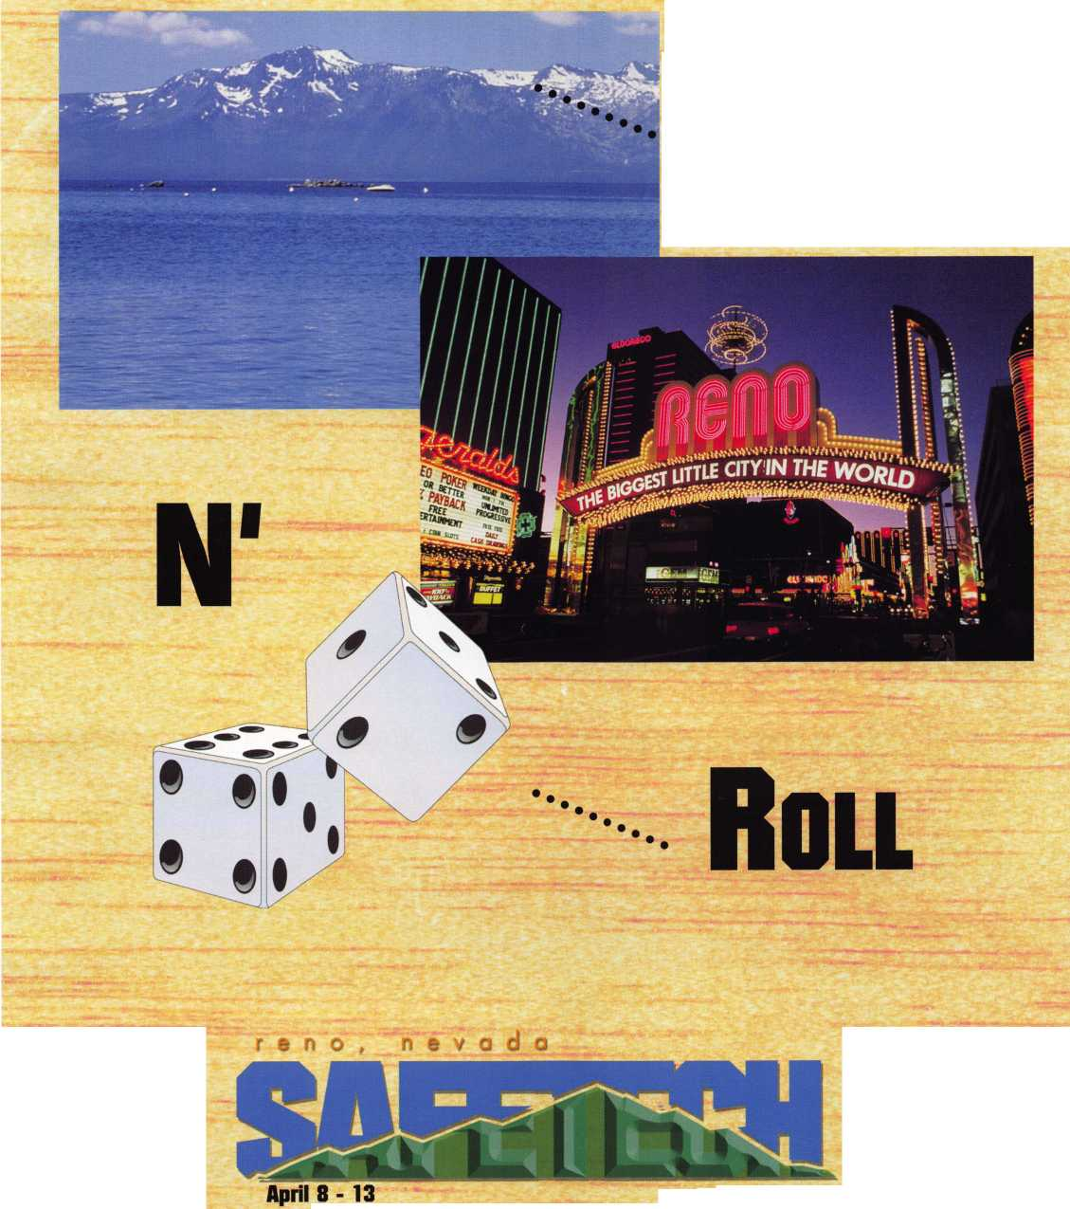

**Hickok’s New Generation STAR transports you with the factory tool for programming keys to  
Ford-Lincoln-Mercury and Mazda vehicles with passive anti theft systems (PATS).**

**-Tf Program vehicle keys through Model Year 2001 with Hickok’s NGS Model 800-8LA-$1995**

'js **Update your existing software-the 2001 Complete New Model Ford Software Update Model 80LA-$895**

**800/342-5080**

**HICKOK**

**iiurnoonnATcn**

[www.hickok-inc.cor](http://www.hickok-inc.cor)

,*reUPuc,v~

»»c«i0^aTe \.»e'

**liimn**

***Jk***

